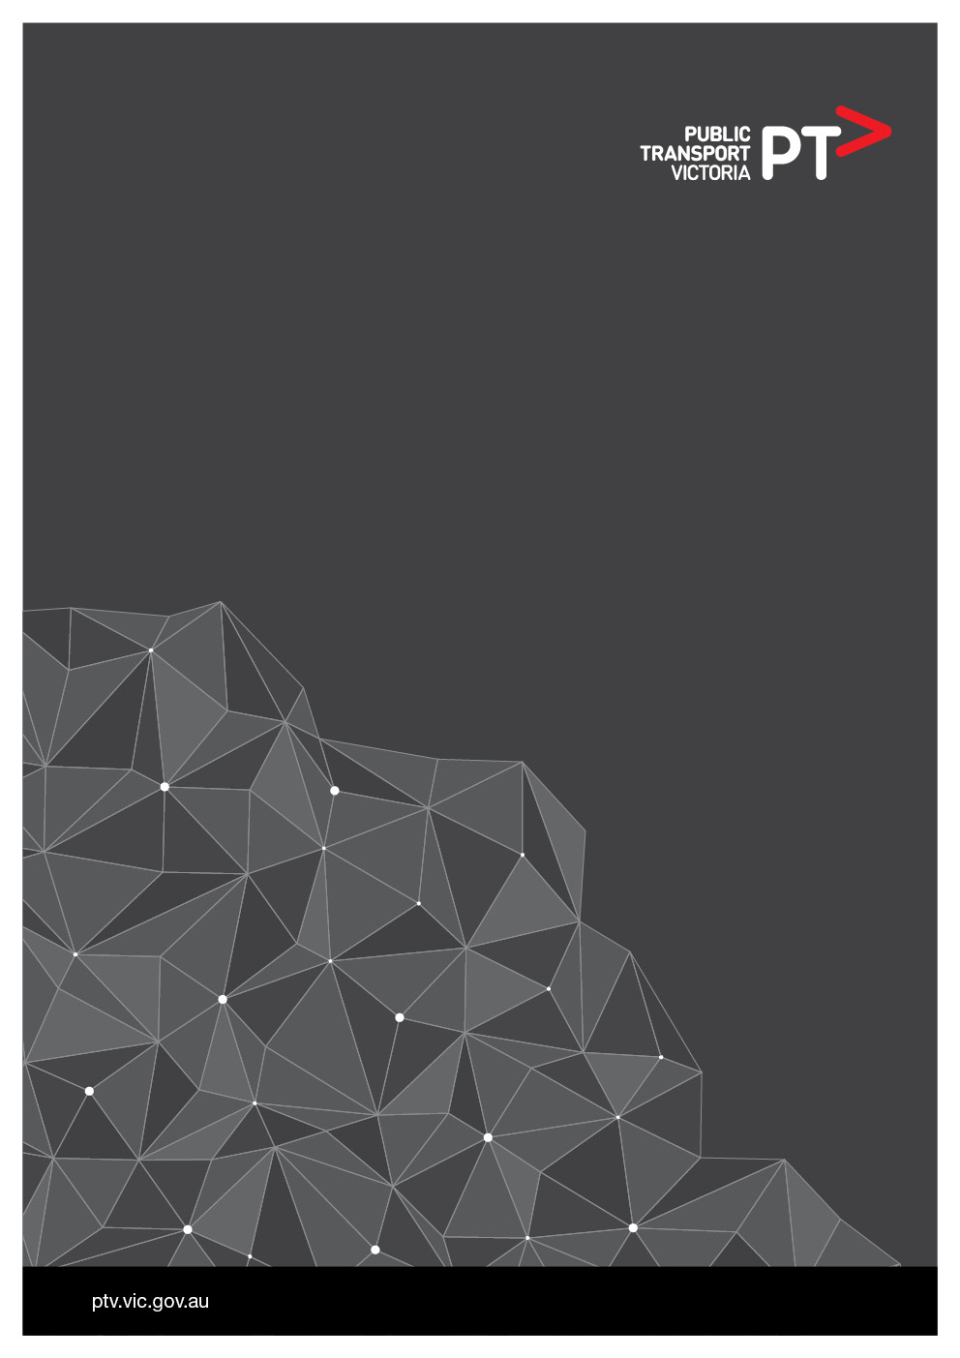

Operator Payment System Modernisation

**Solution Architecture Design** (SAD)

|  |  |  |
| --- | --- | --- |
| **Name** | **Signature** | **Date** |
| PTV Enterprise Deign Authority (EDA) |  |  |

Document information

| **Item** | **Details** |
| --- | --- |
| TRIM Reference |  |
| Document Owner | Vikas Sachdeva |
| Document Author | Vishal Shanbhag (Solution Architect),  Amit Paranjape (Business Architect) |
| Document Contributor | Vikas Sachdeva |
| Version | 4.3 |
| Issue Date | 21/06/2019 |

Document reviewer list

| Name | Position | Date |
| --- | --- | --- |
| Sreekanth Gopalakrishnan | Manager Enterprise Architecture |  |
| Vikas Sachdeva | Senior Solutions Architect |  |
| Jim Karambelas | Infrastructure Services Manager |  |
| Pravin Albuquerque | Business Analyst |  |
| Ashish Khurana | Program Manager |  |
| Anil Bellamkonda | Lead Application Technical Specialist |  |
| Carsten Boeving | Manager Risk, Security and Compliance |  |
| Satya Chunduru | Information Architect |  |
| Peter J Binstead | Manager Application Services |  |
| David Arblaster | Data Scientist |  |

Document distribution list

| Name | Position | Date |
| --- | --- | --- |
| Vikas Sachdeva | Senior Solution Architect |  |
| Ashish Khurana | Program Manager |  |
| Yandong Fan | Sr. Enterprise Architect |  |
| Sreekanth Gopalakrishnan | Manager Enterprise Architecture |  |
| Jim Karambelas | Infrastructure Services Manager |  |
| Pravin Albuquerque | Business Analyst |  |
| Anil Bellamkonda | Lead Application Technical Specialist |  |
| Carsten Boeving | Manager Risk, Security and Compliance |  |
| Satya Chunduru | Information Architect |  |
| Peter J Binstead | Manager Application Services |  |
| David Arblaster | Data Scientist |  |

Revision history

| Version | Date | Author | Description |
| --- | --- | --- | --- |
| 0.3 | 15/03/19 | Vishal Shanbhag | Initial Draft |
| 0.12 | 23/04/19 | Vishal Shanbhag | First Draft |
| 1.0 | 26/04/19 | Vishal Shanbhag | Draft for EDA review |
| 1.1 | 27/04/19 | Vishal Shanbhag | Minor changes |
| 2.0 | 10/05/19 | Vishal Shanbhag / Amit Paranjape | Incorporated EDA offline review comments |
| 2.1 | 15/05/19 | Vishal Shanbhag | Minor update to incorporate Jim’s comments |
| 2.2 | 20/05/19 | Vishal Shanbhag | Updated to reflect the feedback from OPS team members. |
| 3.0 | 10/06/19 | Vishal Shanbhag | Released version for EDA. |

**Table of Contents**

1 Executive Summary 7

1.1 Project Background 7

1.2 Design Highlights 7

1.3 Risk Assessment 7

1.4 Key Architecture Decisions and Compliance 7

2 Solution Context 10

2.1 Related Documentation 10

2.2 Key Architectural Requirements 11

2.3 Assumptions 12

2.4 Constraints 13

2.5 Dependencies 13

2.6 Issues 13

2.7 Risks 14

2.8 Items to be covered in next phase 18

3 Solution Overview 20

3.1 Baseline (Current) Solution Overview 20

3.2 Target (To-Be) Solution Overview 22

3.3 Migration Plan 23

4 Business Architecture 26

4.1 Business Functions/Services 26

4.2 Business Processes 27

4.2.1 End-to-End business Process 28

4.2.2 Contract Plan Set up 29

4.2.3 Contract Set up 30

4.2.4 Financial Processing 31

4.2.5 Contract Variations : Modify Contract 31

4.2.6 Reference Data Management and Indexation Processing 32

4.2.7 Integration Touch Points 33

4.2.8 Portals 33

4.2.9 Others 34

5 Data Architecture 35

5.1 Conceptual Data Model 36

5.2 Logical Data Model 39

5.3 Data Dissemination Matrix 41

5.4 Application Data Matrix 44

5.5 Data Flow Diagrams 45

5.6 Data Migration Plan 47

5.6.1 Methodology 48

6 Application Architecture 50

6.1 Application Components 50

6.1.1 User Channels 51

6.1.2 Process Layer 51

6.1.3 Integration Layer and Gateways 51

6.2 Integration Architecture 52

6.2.1 Pega via CenITex Federated Identity Manager 53

6.2.2 Pega and Oracle Financials 54

6.2.3 Pega and Email Service (AWS SES) 56

6.2.4 Pega and Printer (Via Email Service) 57

6.2.5 Pega, BIX and Reporting Database 58

6.2.6 Pega and Report Generator 59

6.2.7 Pega and Report Object Repository 60

6.3 Presentation Architecture 62

6.3.1 Pega Case Manager Portal 63

6.3.2 Pega Designer Studio 63

6.3.3 Reporting Portal 63

7 Technology Architecture 65

7.1 Environments 65

7.1.1 Hardware (Virtual Server) Specifications 66

7.1.2 AWS Service Specifications 68

7.1.3 Software Specifications 69

7.2 Infrastructure Architecture 72

7.2.1 Production 73

7.2.2 Pre-Production (Production Support) 76

7.2.3 Systems Integration Test / User Acceptance Test / Training 78

7.2.4 Development / System Test 80

7.2.5 DevOps 82

7.3 Operations Architecture 84

7.3.1 Monitoring 84

7.3.2 Logging 84

7.3.3 Performance Management & Capacity Planning 85

7.3.4 Data Archiving Strategy 85

7.3.5 Server Patching 85

7.3.6 Backup & Recovery 85

7.3.7 Disaster Recovery 86

7.3.8 Business Continuity 86

8 Security Architecture 87

8.1 Network Security 87

8.2 System Security 88

8.3 Data Security 89

8.3.1 Data at rest 89

8.3.2 Data in Transit 91

8.3.3 Exceptions 91

8.4 Application Security 91

8.4.1 Access 91

8.4.2 Authentication 91

8.4.3 Authorisation 91

8.5 Time Source Security 92

8.6 User Client Security 92

9 Glossary, Appendix & Attachments 93

9.1 Glossary 93

9.2 Appendix 94

# Executive Summary

## Project Background

The State of Victoria operates its key Transport Services through private outsourced franchise operators which are managed under commercial contract agreements. The effective operation of Trains, Trams, Buses, Ferries and some “Other” services are underpinned by service contracts that specify the type, quality, location and frequency of services to the public. There are multiple systems currently used to manage sub sets of these Operator Contracts and the payment associated with them. These systems do not meet the future business needs of PTV in managing the processing and payment of Operator contracts, due to ever increasing rate of change to commercial agreements.

PTV is increasingly reliant on manual workarounds which increase risk, increase fragmentation of processes and reduce operational efficiency. The current arrangements make reconciliation complex and time consuming, in addition to PTV aiming to continually improve controls and auditability across all systems.

Operator Payment System Modernisation is an initiative to replace the current PTV systems which manages Payment component of Franchise Operator Contracts. This system will be replaced with an industry leader BPMS technology solution based on Pegasystems PRPC platform, and once deployed will be known as the Service Provider Payment System (SPPS).

## Design Highlights

The specific architectural highlights of this project are:

* The solution follows the principle of “Cloud Preference”. The SPPS solution will be delivered as a managed services solution on AWS, so the vendor takes the responsibility for hosting, initial set-up, configuration and deployment, ongoing operations and any other application or infrastructure related tasks and purchases.
* The solution will enable access to the system over a secure Web Portal for PTV internal users (~66) and external users (~100 - 500). Internal users will be authenticated via WoVGIDaas service and external users will login via email Id and passwords maintained in Pega database.
* In alignment to CIO Architecture Principles “Process-Centric Business Architecture”, SPPS solution will have multiple processes managed as Pega Case Management functions. As part of this process, all the exiting manual and automated processes are reviewed and improved/align towards the target business requirements.
* The solution will enable Payment Acknowledgement feature for Finance team to receive a success/failure status from Oracle Financial for invoices released for payment.
* The solution will allow the Finance and Pacman teams to inspect and interact with the data produced by the solution in order to perform deep data analysis and ad-hoc reporting

## Risk Assessment

Please refer to section 2.7 for Risks identified for SPPS solution

## Key Architecture Decisions and Compliance

The table below captures key decision applicable to Operator Payment System’ Architecture.

| # | Decision Description | Alignment to Architecture Principle |
| --- | --- | --- |
| SA-AD1 | SPPS will be delivered on a cloud Platform. | This decision aligns to the principle of “Cloud Preference”. |
| SA-AD2 | SPPS based on commercial off-the-shelf platform (Pega) with configurations/ customisation. | This decision aligns to the principle of “Adoption of commercial off-the-shelf solution”. |
| SA-AD3 | Authentication – SSO: Solution will have internal PTV users (66) and external users (Service Providers 100 - 500).  Solution will provide Single sign-on for internal users for Pega and Reporting parts of the solution. Internal users will be authenticated via WoVGIDaas service and external users will login via email Id and passwords maintained in Pega database.  Authentication for internal users will be done using Federated Identity management user Authentication service (SAML 2.0+). Authorisation for Pega will portal will be managed in Pega and for Reporting solution authorisation will be controlled by SharePoint. | This decision aligns to the Principle of “Conformance to Technology Standards”. |
| SA-AD4 | File Transfer – Use AWS S3 bucket to transfer information between AWS and CenITex infrastructure via REST over HTTPS. | This decision aligns to the Principle of “Layers of Security”. |
| SA-AD5 | Outgoing email: SPPS will utilise AWS SES feature to send email notifications to internal users and service providers. | This aligns to the Principle of “Conformance to Technology Standards” |
| SA-AD6 | SPPS will be web-based solution. | This aligns to the Principle of “Promote Thin Client” |
| SA-AD7 | All PASS related reports in Business Objects will be migrated to new SPPS solution. This will allow de-commissioning of Business Objects when PASS OPR will move to a new platform. | This aligns to the Principle of “Conformance to Technology Standards” |
| SA-AD8 | SPPS will be hosting on Amazon Web Services (AWS) platform. | This decision aligns to the principle of “Cloud Preference”. An assessment was done by vendor and recommendation to use AWS over Azure was provided due to similar cost and high risk of first Pega deployment on Azure. |
| ~~SA-AD9~~ | ~~SPPS will be utilize the MS SQL Server Enterprise Edition under Service Provider License Agreement (SPLA) arrangement with Microsoft~~ | ~~Cost benefit analysis presented for 3 options to EDA members and agreed with SPLA option~~ |
| SA-AD10 | SPPS will host their own reporting solution rather than creating a dependency on DAP program. | Options discussed with EDA members and chosen to go with SPPS Reporting Solution. |
| SA-AD11 | SPPS will leverage the existing Konica Minolta SafeQ “email submit” print functionality to deliver printing capability | Options discussed with EDA members. Decision aligns to the principles:   * “Adoption of commercial off-the-shelf solution”; and * “Interoperable, modular and reusable design” |
| SA-AD12 | SPPS will update the deployment topology to remove sharing between Pega and Reporting databases, and utilise PostgreSQL databases on RDS | Options discussed with EDA members. Decision aligns to the principles:   * “Adoption of commercial off-the-shelf solution”; * “Able to adapt for change and growth”; * “Cloud preference”; and * “Resilience” |
| SA-AD13 | SPPS will split reporting implementation into separate Report Object Repository and analytics components. Analytics functionality to be implemented in Qlik Sense. | Options discussed with EDA members. Decision aligns to the principles:   * “Adoption of commercial off-the-shelf solution”; * “Able to adapt for change and growth”; * “Cloud preference”; and * “Resilience” |
| SA-AD14 | PTV will authorize a single SPPS-specific email address to send outbound emails using the suffix ptv.vic.gov.au via AWS SES. | Allows stronger alignment with the principles:   * “Layers of Security”; and * “Presenting a consistent face for PTV” |
| SA-AD15 | SPPS will deliver static transactional reports using and JasperReports Library (using AWS Lambda), and implement data transformation and cleansing required for reporting and analysis of Pega data using JasperETL (using AWS Lambda) | Options discussed with EDA members, **but currently not endorsed**.  Aligns to the principles:   * “Adoption of commercial off-the-shelf solution”; * “Cloud preference”; and * “Resilience” |

# Solution Context

## Related Documentation

Below is the list of documents which were used as source of baseline information for this Solution Architecture Design.

| # | Document | Description/ Location | Document from Phase |
| --- | --- | --- | --- |
| SA-RD1 | OPSM Integration Architecture v0.2.docx | AS-IS High Level Integration Architecture | CD Phase |
| SA-RD2 | Appendix A Part 1 - OPSM Requirements_RFP.docx | **Section 1.4**  Functional Requirements for OPSM Solution | RFP Phase |
| SA-RD3 | Appendix A Part 1 - OPSM Requirements_RFP.docx | **Section 1.5**  Non-Functional Requirements for OPSM Solution | RFP Phase |
| SA-RD4 | PTV Checklist-Application Security Requirements.XLS | Checklist for Application Security Requirements | CD Phase |
| SA-RD5 | PTV Checklist-Cloud Security.XLS | Checklist for Cloud Security | CD Phase |
| SA-RD6 | PTV Standard-Web Application Security.DOC | Standard Web Application Security | CD Phase |
| SA-RD7 | DOC-08-82663 -- Oracle Financials Accounts Payable Interface Format.docx | File Format description for Payment File that OPSM solution will send to Oracle Financial | Inception |
| SA-RD8 | PTV AWS Reference Architecture v0.2.pdf | PTV’s Reference Architecture for AWS based solutions | Inception |
| SA-RD9 | Data Migration Strategy | Data migration strategy for moving PASS data to OPSM solution | Inception |
| SA-RD10 | OPSM Solution Options 1.0 | Solution Options presentation | Inception |
| SA-RD11 | Network Traffic Standard v1.7.docx | CenITex network traffic standards for the Shared Government Platform (GSP) | Delivery |
| SA-RD12 | Email Printing EDA Pack v1.pptx | Options for variation to the document printing architecture presented to the PTV EDA | Delivery |
| SA-RD13 | SPPS DB Architecture Variation EDA Pack v1.pptx | Options for variation to the database architecture presented to the PTV EDA | Delivery |
| SA-RD14 | SPPS Reporting Architecture Variation EDA Pack v1.pptx | Options for variation to the reporting architecture presented to the PTV EDA | Delivery |
| SA-RD15 | SPPS - Oracle Fin Integration BRD_v3.docx | BRD for Oracle Financial file formats | Delivery |
| SA-RD16 | Email Trust EDA Pack v1.pptx | Options for authorizing emails to be send from AWS presented to the PTV EDA | Delivery |
| SA-RD17 | SPPS Reporting Additions v1.pptx | Options for addition of JasperReport Library and JETL to the reporting architecture presented to the PTV EDA | Delivery |

## Key Architectural Requirements

The requirements that are key to SPPS solution architecture are as follows

* Functional
* The solution should provide a self-service portal for external users to register and reset password.
* The solution should provide function of bulk printing documents overnight without any user intervention.
* All the notification emails should be sent via a @ptv.vic.gov.au account.
* The solution should have mechanism to configure security roles to control authorisation to the application.
* The solution should have mechanism to receive payment acknowledgements from Oracle Financial system.
* Solution should generate and store non-editable audit trace for all the components of the solution - application (Pega and reporting), infrastructure (logs etc.) and Data migration.
* Non-Functional
* The solution should be hosted on cloud infrastructure, as per Cloud Preference principle. There are few systems such Oracle Financial, Indentity Manger and Print Server, which will stay in CenITex infrastructure. The solution needs to integrate with these systems.
* The solution must support 99.5% availability.
* The solution should also be accessible for internal and external users over a secure web interface.
* The solution should have robust and leading Security mechanisms be in place to protect PTV’s operations and assets.
* Any custom utility (i.e. file transfer) should be managed by vendor and liase with infrastructure provider (e.g. CenITex) for any infrastructure related support.
* All the solution data should reside with-in Australia and should not accessed outside of Australia.
* System must adhere to WCAG 2.0 accessibility requirements.

## Assumptions

| # | Assumption |
| --- | --- |
| SA-A3 | CenITex will provide access to authenticate PTV users via WoVGIDaaS (Whole of Victorian Government Identity as a Service) to facilitate single-sign-on. |
| SA-A7 | Decommissioning approach and solution is outside the scope of this Solution Architecture. |
| SA-A8 | Data printed as part of Bulk Printing function in SPPS solution is secured at physical level *(access to building or print area)* and will follow same security protocol as for PASS. |
| SA-A9 | Solution is designed considering Pega Perpetual license and all the infrastructure will be hosted in AWS instead of Pega cloud. |

## Constraints

| # | Constraint | Description |
| --- | --- | --- |
| SA-C1 | Payment File | No changes can be made to Payment File format that is exchanged between Pega and Oracle Financial, however, encryption of the file will be added. |
| SA-C2 | Authentication | CenITex WoVGIDaaS only provides SAML interface to authenticate users and does not support LDAP queries over SSL. |
| SA-C3 | Internal User Portal | Internal user portal must not be accessible from outside PTV network. |
| SA-C4 | Bulk Printing | The printer hardware in PTV does not support document printing via polling a document store. |

## Dependencies

| # | Dependency On | Description |
| --- | --- | --- |
| SA-D1 | CenITex | The solution has dependency on CenITex to facilitate integration between AWS and CenITex integration touch points and existing infrastructure which will remain part of SPPS solution. |
| SA-D2 | Oracle Financial | The solution has dependency on Oracle Financial team to facilitate integration AWS and Oracle Financial including development of Payment Acknowledgment feature. |
| SA-D3 | Pega | The solution has dependency on Pega to provide product fixes, if required. |

## Issues

| # | Issue |
| --- | --- |
|  |  |

## Risks

| # | Risk | Likelihood | Owner | Severity | Status | Potential Impact/Mitigation Strategy |
| --- | --- | --- | --- | --- | --- | --- |
| SA-R1 | There is a project undergoing to replace current Printers with Secure Printing, this may result in change in approach to bulk printing. | Unlikely | PTV | Minor | Closed | Architecture is capable of sending print to any printer.  Update 22/11/2016: Printing will leverage email-print via SafeQ to the Finance Printer. |
| SA-R2 | SPPS email volume may hit the AWS SES threshold, as it is a shared service for single PTV account. | Unlikely | PTV | Minor | Closed | An assessment will be planned before Go Live.  Update 22/11/2016: SES Limit set for SPPS account only, and volume/rate limits can be lifted by application to AWS. |
| SA-R3 | Design phase may influence an architectural decision and may require changing an integration approach or solution approach. | Unlikely | PTV, Vendor | Moderate | Closed | This is unlikely but may occur, as design is influenced by business requirements and technology choices made in this architecture. If any of these changes, this document will be updated and circulated for review. Few things identified are Multi factor authentication, third party user accounts lifecycle, outcome of Security Impact Assessment.  Update 22/11/2016: Several architectural chances have been made based on deeper analysis of requirements, product limitations, and improved implementation methods. Major changes outlined in Section 1.4. |
| SA-R4 | Lifecycle of external users cannot be fully controlled by PTV and a solution to control unauthorised access by an external users is yet to be finalised | Likely | PTV, Vendor | Moderate | Open | Business teams will work with Operators/Service Providers to define the process.  Technology measures will be in place as recommended by SIA like, password expiry, Captcha, in- activity, email validation etc.  Update 22/11/2016: Service Provider Portal is to be delivered in OPSM Release 4. Controls for lifecycle management of external users to be updated when portal requirements are groomed. |
| SA-R5 | The integration with S3 may turn out to be quite complex. | Unlikely | PTV, Vendor | Minor | Closed | Vendor will confirm if there are any issues with this design pattern and CenITex will need to engage for SFTP as an alternate option.  Update 22/11/2016: Integration with S3 achieved as per design specified in section 6.2.2. |
| SA-R6 | Delay in design and delivery timeframes from integration partners (CenITex and Oracle Financials) can delay the overall delivery of SPPS | Likely | PTV, Vendor | Moderate | Closed | There will be contractual arrangement with integration partners and planning activity will be performed to align the dates.  Update 22/11/2016: Managed by project delivery |
| SA-R7 | WACG2.0 is one of the mandatory NFRs and that has extensive list of requirements.  WACG requirements are new to PTV and may take time to understand and review | Likely | PTV, Vendor | Moderate | Closed | The solution may take longer in meeting Accessibility requirements, if any issues/limitations are found with user facing off-the-shelf products which may require fixes from software vendors. Workshops are scheduled with multiple parties within PTV and vendor.  Update 22/11/2016: Managed by project delivery |
| SA-R8 | SPPS support arrangements are not clarified | Unlikely | PTV, Vendor | Moderate | Open | Support arrangements are currently under discussion and will be closed as a part of contract finalisation. |

## Outstanding Items

| # | Outstanding Item | Description | Status |
| --- | --- | --- | --- |
| ~~SA-O1~~ | ~~Security Impact Assessment (SIA)~~ | ~~SIA will be conducted in next phase hence this document will be updated reflecting the outcome of the assessment~~ | ~~Closed~~ |
| ~~SA-O2~~ | ~~Data Architecture~~ | ~~Pega inception (current phase) only captures high level requirements and use cases. Next phase Elaboration and construction phase will gather detailed information regarding fields and forms. Data Architecture section will be updated accordingly. This section will also cover the recommendations from Information and privacy recommendations in next phase.~~ | ~~Closed~~ |
| ~~SA-O3~~ | ~~Archiving~~ | ~~As a part of elaboration phase data information will be captured, Retention , archiving and purging frequencies will be captured as a part of Data Architecture~~ | ~~Closed~~ |
| ~~SA-O4~~ | ~~CenITex Infrastructure and functionality design~~ | ~~Integration touch points and Infrastructure required to host in CenITex will be covered as a part of next phase. A formal engagement will timelines will be initiated after business case approval.~~ | ~~Closed~~ |
| SA-O5 | PASS systems (PASS BUS IT and PASS Payments) decommissioning | Decommissioning of existing system is not part of this document, however will be covered as a separate activity with-in SPPS Program. | Open |
| SA-O6 | Business Continuity | Business Continuity plans will be managed outside of this document and managed by different departments involved in the solution. A detailed review of the business continuity (if required) will be reviewed as a part of implementation phase. | Open |
| ~~SA-O7~~ | ~~Back-up~~ | ~~Backup frequencies will be defined in next phase.~~ | ~~Closed~~ |
| ~~SA-O8~~ | ~~Multifactor Authentication~~ | ~~Multi factor Authentication will be assessed as a part of SIA~~ | ~~Closed~~ |
| SA-O9 | Lifecycle of external users | Controls for lifecycle management of external users to be updated in OPSM Release 4 when portal requirements are groomed. | Open |
| SA-O10 | Legal assessment for auditing requirements | Legal assessment for auditing requirements will be done as a part of next phase. | Open |
| SA-O11 | Encryption and other key matrix (ownership and sharing) | AWS and application Encryption and access key matrix will be produced prior to implementation. | Open |
| ~~SA-O12~~ | ~~Monitoring tools~~ | ~~Detailed monitoring tools will be added in next phase.~~ | ~~Closed~~ |

# Solution Overview

## Baseline (Current) Solution Overview

There are multiple systems, spreadsheets and manual processes used to calculate payments related to the 1,700+ contracts between PTV and the 600+ franchise operators.

While contracts cover various modes of transport e.g. Train, Tram, Bus etc., within each mode there are separate categories of contracts.

Current operator contracts categories include:

* Metropolitan, School and Regional buses: approximately 500+ companies associated with 1,600+ contracts are engaged by the State Government to provide metropolitan route buses, country and regional town services, school buses, airport bus services and the metropolitan Night-Rider service.
* There are 18 separate contract types or templates used across this category of bus services. These types differ with regard to their payment arrangements; timing of payments; payment formulae and calculations and the number and type of variables which impact payment calculations.
* Melbourne suburban trains: The State Government has a contract with Metro Trains Melbourne (MTM) to deliver train services on the metropolitan suburban network.
* Regional trains and inter-town coaches: V/Line operates a network of passenger trains and inter-town coach services within Victoria. V/Line is owned by the V/Line Passenger Corporation which is a Government statutory authority.
* Melbourne Trams: The State Government has a contract with Keolis Downer EDI (KDR) to provide tram services in Melbourne.
* Ferry: PTV is also responsible for managing the contract for a timetabled ferry service in Western Port Bay. Inter-Island ferries have a ten year contract to operate the service from Stony Point to French Island and Cowes on Phillip Island.
* Various other contracts related to Depots, Southern Cross Station, Inter Government contracts etc.

The current systems were originally designed some 14 years ago to support much older contract types, such as the 1999 MR2 Train/Tram refranchising agreements and older metropolitan, school and regional bus service contracts and are not being used for newer contract arrangements (e.g. Transdev and newer Metropolitan bus contracts) due to the high cost of re-build as the current systems do not lend themselves to be adapted for contracts with notable differences to their payment constructs.

Over time, it has become apparent that the operation of the public transport system involves significant variation to commercial agreements as a result of changing demand, need for greater flexibility for ad hoc services, performance adjustments, operational changes (e.g. vehicle replacement) and other escrow arrangements.

The PASS applications were bespoke systems and have a reliance on specialised support. They are complex, inflexible and difficult to maintain. The systems are split across numerous platforms and often changes have to be applied multiple times due to systems duplication.

The PASS system is responsible for the calculation, consolidation, approval and disbursement of payments which are then passed into the financial system (Oracle Financials) for payment to be made to the operators.

The current suites of systems include:

* Monthly Statistical Returns are submitted by Bus Operators for some types of Contracts. These returns contain information about passenger numbers, revenue and subsidy claims, and are required to be submitted under the terms and conditions of some Bus Contracts. PTV tracks these Monthly Statistical Returns for a variety of purposes.
* PASS Payments Train and Tram to manage Metro Trains, VLine trains and Yarra Trams contracts and payments
* PASS Bus IT to manage Country and Regional bus services, Airport bus services, NightRider bus services, school bus services and Ferry services and associated payments
* Various Excel spreadsheets to manage certain contractual arrangements
* Various small systems to manage Vehicle Ceiling prices, Driver Long Service Leave, Map Info to manage service changes etc.
* Business Objects for the delivery of a vast number of operational and executive reports utilised by the Finance and the Network Operations teams as well as distributed to the Operators, relating to contracts and changes, payment calculations and disbursements, tax invoices, revenue reporting, transport usage audits, systems administration reporting etc.
* PASS Operator Performance Regime (OPR) to process data related to the performance of delivered services, incidents and mitigation data related to service performance.
* OPA systems: Which in combination process the large volumes of actual transport service data derived primarily from vehicle tracking systems, validate, transform and store the data (ETL) in cubes for further processing, analytics, business intelligence, presentation and reporting. The performance data is compared to the contracted, planned services and verified against performance targets and thresholds to determine net impact on passengers from a reliability and punctuality perspective.
* PASS Compliance
* OPA PrePro Systems
* OPA Sandpit Systems.
* Affinitext tracking and management of contract documents, clauses and to trigger contract compliance activities e.g. renewal of safety certification.

The diagram below shows the current Operator Payment System:



Figure 1: Baseline (Current) Solution Overview

## Target (To-Be) Solution Overview

OPSM is an initiative to implement ‘State of Art’ BPMS technology and engage a vendor with high capability and extensive experience in delivering this technology. Through various steps of procurement process and engaging Industry leaders in delivering BPMS technology solutions, PTV has made a decision to use Pega PPRC as base platform for case management and business rules management.

The key objectives of to-be solution are:

* To provide a solution that withdraws manual interactions with various systems and provides a unified system for managing Operator Payments and related reports
* To provide a web portal for External users (aka Operator or Service Providers)
* To provide a unified web portal for Internal users (Finance and Pacman teams)
* To provide a mechanism to receive payment acknowledgment from Oracle Financials
* To host the solution in a Cloud Environment to make it highly scalable and resilient
* To provide agility and flexibility to accommodate a high rate of contract/payment variations
* To provide ability to process complex calculations related to retrospective payments

The system context diagram below shows the target Operator Payment System represents the proposed solution as a single logical system in the context of the external entities with which it interacts.

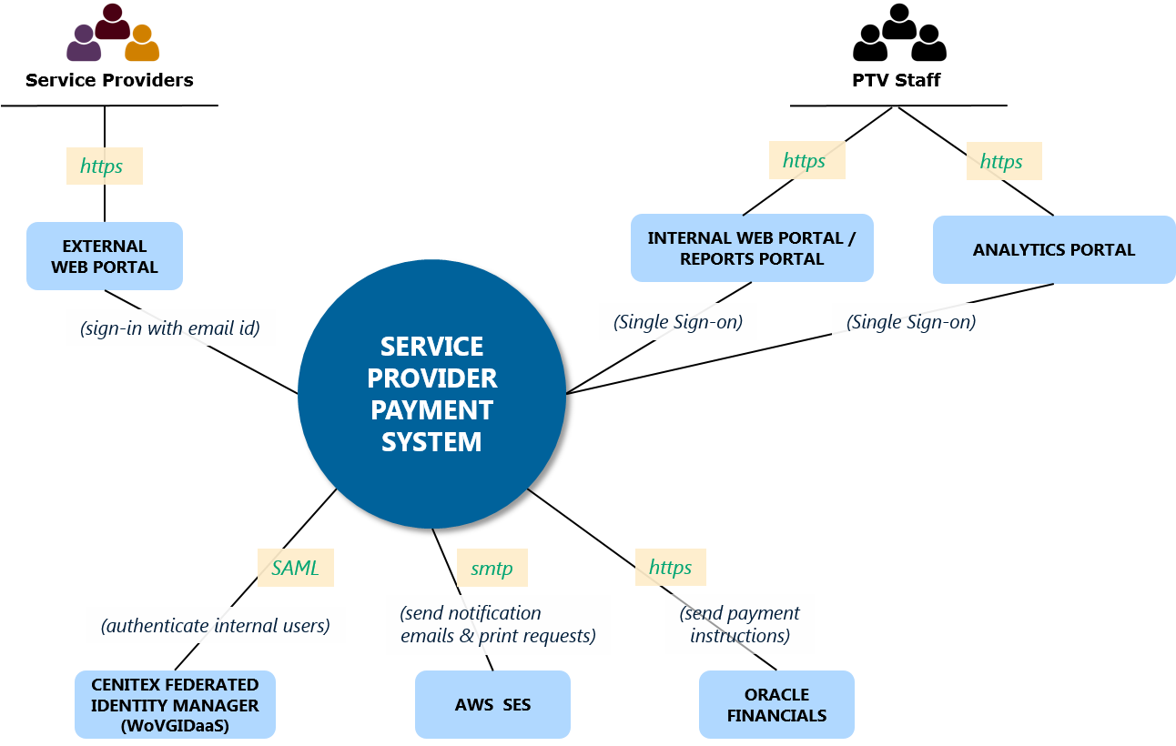

Figure 2: Target (To-Be) Solution Overview

## Migration Plan

This section covers brief details of the proposed migration plan from the Current Solution to Target Solution.

The delivery approach for SPPS solution will be executed majorly based on Pega BPM *(aka SmartBPM)* Methodology, with existing reports migrated to an object store based in Amazon S3 and a new analytics capability provided by Qlik Sense. This release planning for delivering the SPPS solution is agreed with Business stakeholders and is built based upon complexity and volumes of different type of Service Providers and Contracts.

There will be multiple major releases to deliver the SPPS solution and these releases will also have a period of ‘Parallel Run’ to prevent any Financial Risks from materialising. ‘Parallel Run’ is the concept, where two production system (typically AS-IS and TO-BE) runs in parallel for the same business process, but final transaction happens only from the AS-IS system. The end results just before the final transaction are compared for a period of time to establish confidence from the To-be system.

The parallel run exists within the SPPS deployment plan as a substitute for standard Business Verification Testing. A small subset of contracts within each planned release will be managed by the developed SPPS solution within the production environment for a specified duration in *parallel* with the existing payment system (PASS Bus IT, PASS Payments etc.). The output of SPPS *will not* provide input to Oracle Financial instead this output will be compared against that of the existing system as a form of final verification.

If the SPPS solution is successful in producing an output identical to that of the existing system in this parallel run, it will be considered business verified and hence implemented as the primary payment system for all contracts relevant to that release (CRUBS, School Buses etc.).

The SPPS solution will also have a Data Migration stream, which will run in parallel with the Application Development stream and will be executed along with application deployment in Production.

Several incremental releases have been planned for the SPPS solution delivery, which will enable a progressive rollout of business functionality, as follows:

| Release | Business Unit | No of Contracts |
| --- | --- | --- |
| **Release 1** | Country Regional Urban Bus Services (CRUBS) | 140 Contracts |
| **Release 2** | Metro Bus, Ferry and Nightrider | 47 Contracts |
| **Release 3** | School Buses | 1400 Contracts |
| **Release 4** | Train, Tram and Transdev | 5 Contracts |
| Operator Portal | None |

This approach allows PTV to examine and assess the SPPS solution throughout release and gain confidence in its capability earlier in the development process as opposed to committing to development of the entire system without trial.

There will also be an Application / Platform Decommission stream for PASS system. This solution architecture does not capture any details around Application/ Platform for PASS system and will be done separately. The diagram below indicates the sequence in which PASS system will be ready for decommissioning.

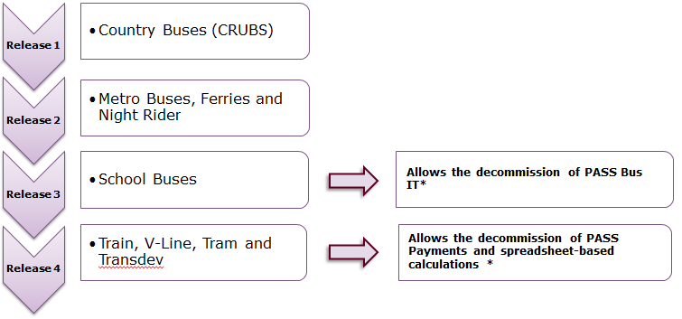

Figure 3: PASS Payments / PASS Bus Decommissioning Strategy

# Business Architecture

## Business Functions/Services

The business function that is affected is shown in the following business blueprint functions



Figure 4: Affected Business Functions / Services

## Business Processes

The diagram below shows all parts of Business Process, which need to be implemented by SPPS solution.

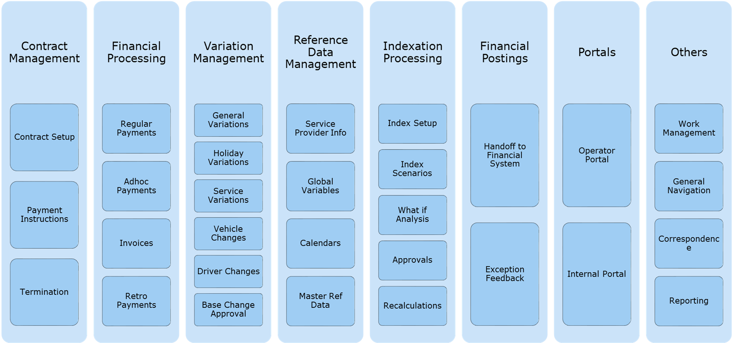

Figure 5: Business Processes

The following sections describe all elements of the business processes depicted above.

### End-to-End business Process

The diagram below shows a high level view of end-to-end business process. Please follow subsequent sections for details around all parts of the business process.

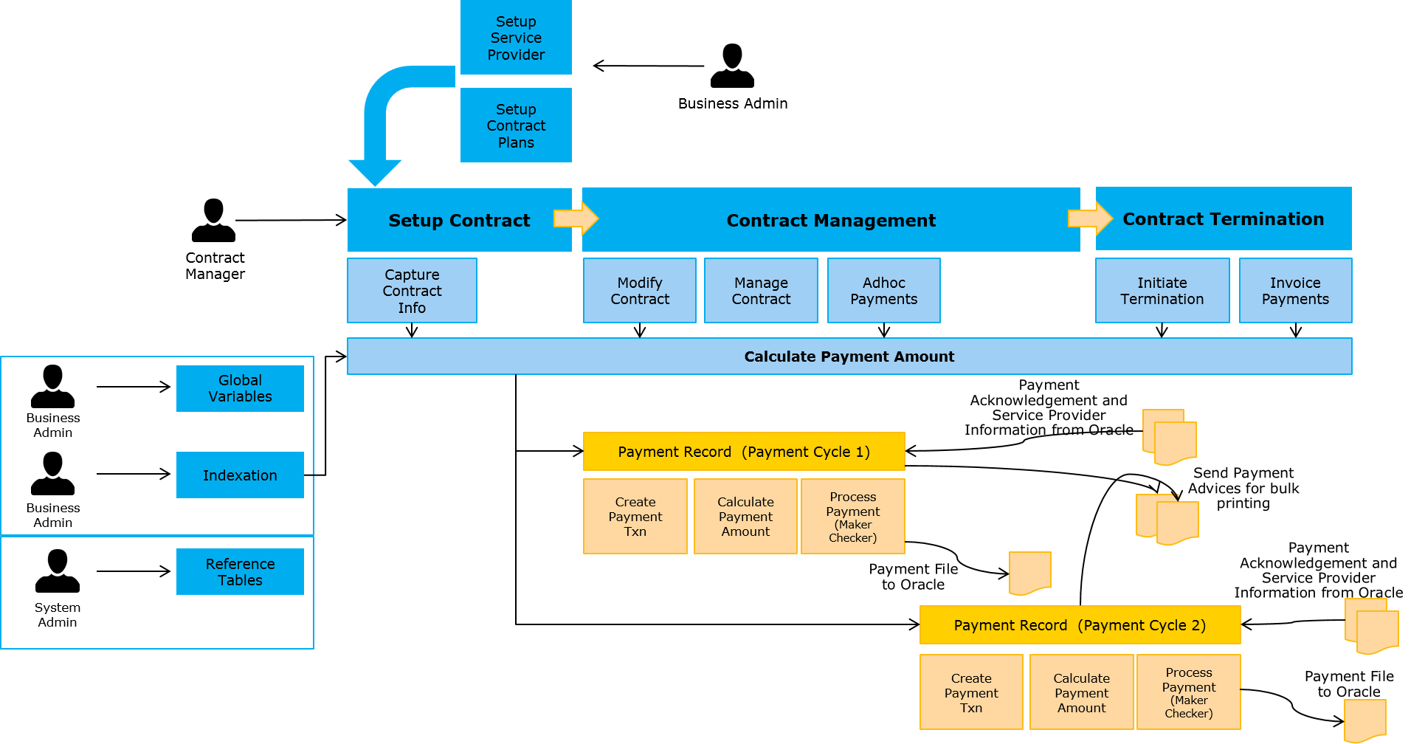

Figure 6: End to End Business Process

### Contract Plan Set up

The SPPS solution will enable the design and configuration of contract plans. User will be able to set up a contract plan and the relevant payment instructions associated with the plan.

The diagram below shows the Contract Plan Set-up process

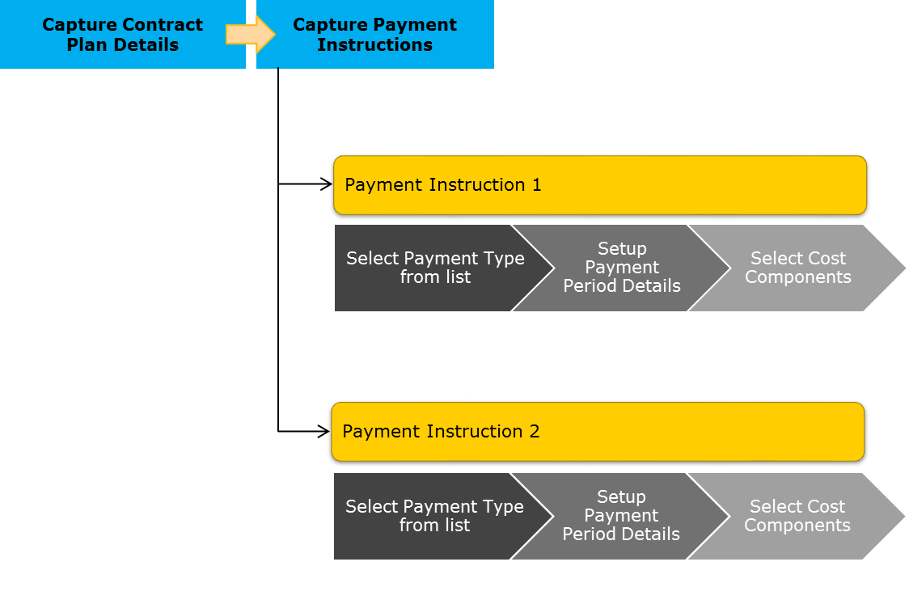

Figure 7: Contract Plan Set up Process

### Contract Set up

The SPPS solution will enable the design and configuration of operator and contract management related processes, such as contract setup, setting up of Payment parameters and contract termination. The processes will be streamlined, tracked and audited via the SPPS Pega platform.

The merits of this solution are that it provides PTV with a 360 degree view related to the management of operator contracts and provides ease of management and reporting. Users will be guided through the process of setting up operators and contract by entering supporting Reference Data related to the contract and other information such the payment parameters, Timetable, Vehicle information, Driver information, Payment Calculation rules, business rules, etc.

The diagram below shows Contract Set up Process.

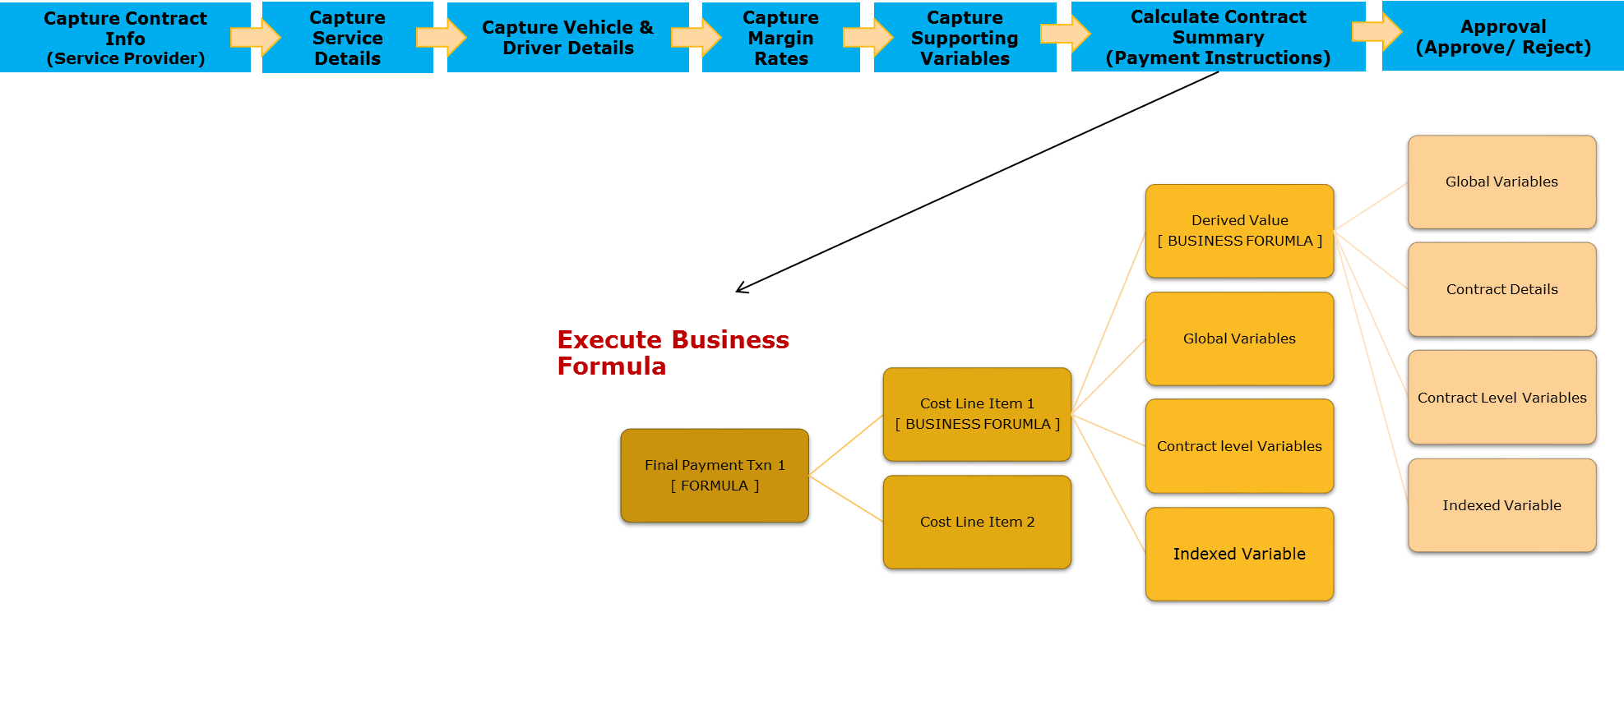

Figure 8: Contract Set-up Process

### Financial Processing

The SPPS solution will be designed to process regular payments for contracts, ability to capture and process Ad-Hoc and Invoice payments from the operators. The system is designed to achieve high efficiency by eliminating human intervention in initiating regular monthly payments, enables business users to update reference data which are a key input in the payment calculations and processing. SPPS solution is also designed to cater to provide a platform to the operators to submit invoices, ability to view invoices from the Operator portal. The solution streamlines the required approvals and sign-offs through the lifecycle of the processes. The solution provisions for handing off the payment details to the accounting engine (Oracle Financials) to process the payments, receive status updates and exception handling in case of payment failure.

The diagram below shows Financial Processing process.

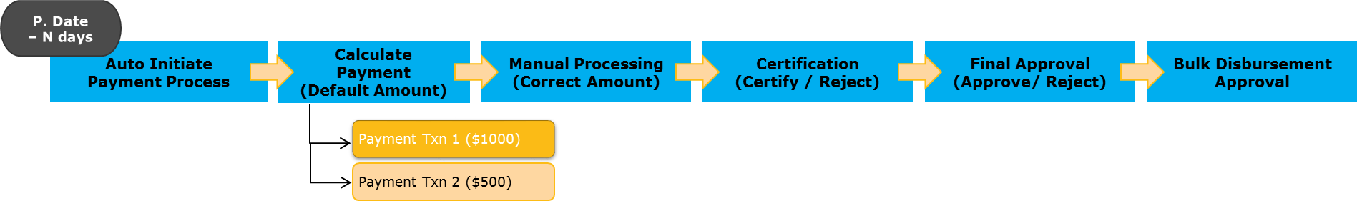

Figure 9: Financial Processing Process

### Contract Variations : Modify Contract

During the lifecycle of the contracts there are numerous variations which are received in form of changes to the parameters which feed to the calculation of the payment amount example Vehicle changes, driver change, school calendar change, service variation etc. Another variation which impacts the payment amount is variation to the indexed values as explained in section 4.2.6. SPPS caters for capturing contract variations and apply required approval process where applicable.

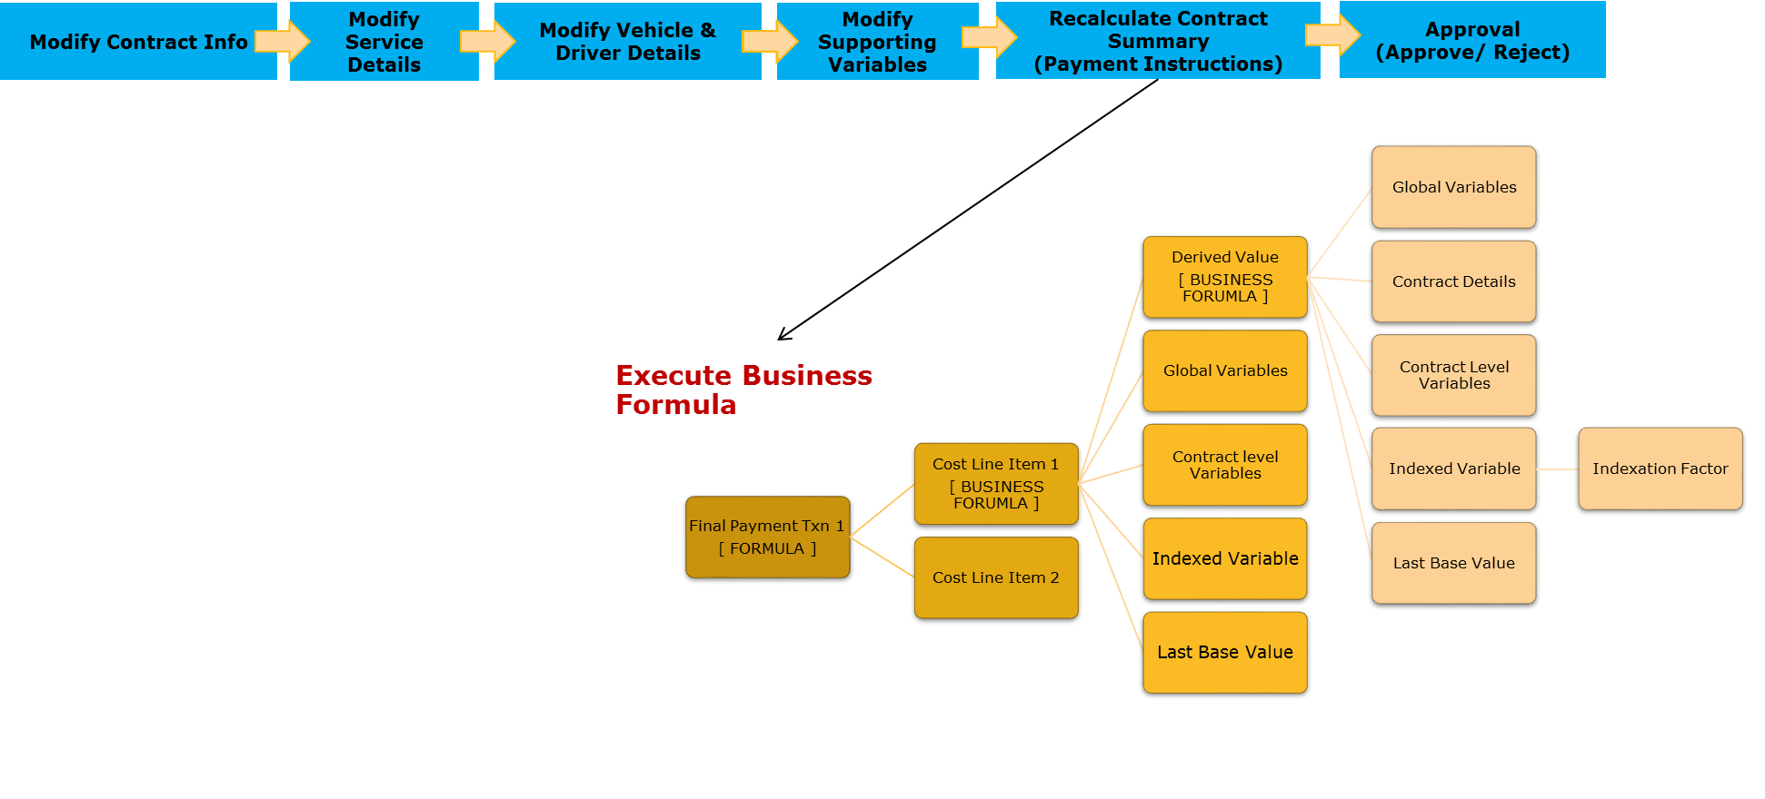

Figure 10: Modify Contract Process

### Reference Data Management and Indexation Processing

The nature of the SPPS solution is such that various components of the solution require requires regular updates from the business and technical users from time to time. The solution caters to capture the updates, initiate Indexation scenarios, provide what-if analysis for the management review and approval and apply the changes for the subsequent payment cycles. These include changes to the indexation tables, global variables, service provider, mater reference data, calendars, etc.

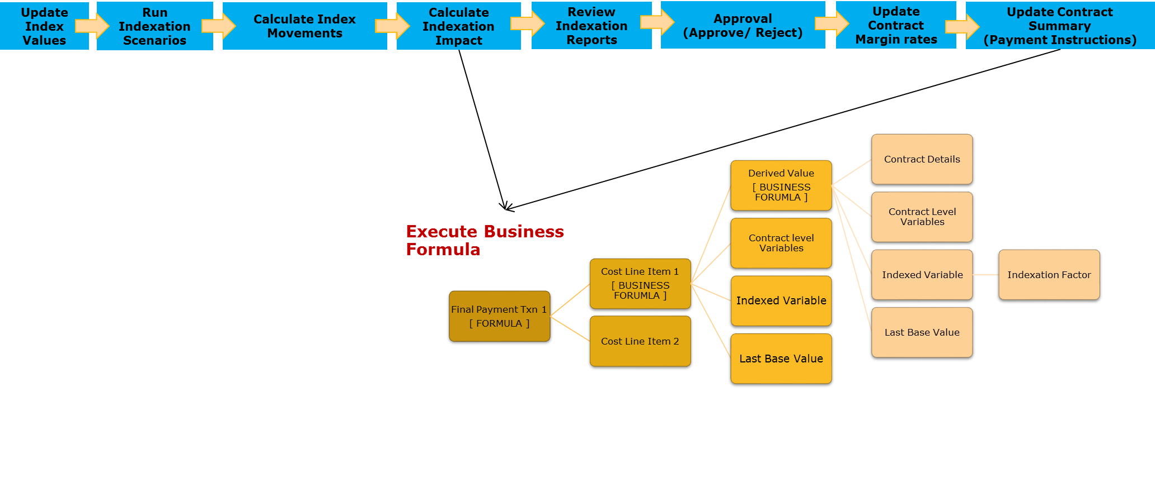

Figure 11: Indexation Processing Process

### Integration Touch Points

Please refer to section 6.1.3 and 6.2 for integration details

### Portals

Please refer to section 6.1.1 for Portal details

### Others

SPPS solution ensures that case and process controls for PTV’s key business processes can be managed efficiently, reducing cost and risk in PTV’s complex environment.

Case management platform provides a central electronic manila folder style view of a case and related information. The case (be it an Regular Payment, Operator Setup, Contract Setup, Manage Contract, Ad-hoc/Invoice Payments, or other future processes.) will provide supporting/related cases, tasks, communications and notifications, work allocation and management, collaborations, reporting and other information. The platform supports automated and prescribed processes as well as dynamic and ad-hoc activity with collaborative decision-making. The case management control in the platform also enables controlled flow and collaboration to ensure case handling is optimised, traceable and, importantly for PTV, secure and auditable.

# Data Architecture

Data within the SPPS solution has been broadly classified as follows:

| Data Category | Definition |
| --- | --- |
| Master Data | Master data describe the people, places, and things that are involved in an organization’s business. Examples include people (e.g., customers, employees, vendors, suppliers), places (e.g., locations, sales territories, offices), and things (e.g., accounts, products, assets, document sets). Because these data tend to be used by multiple business processes and IT systems, standardizing master data formats and synchronizing values are critical for successful system integration. Master data tend to be grouped into master records, which may include associated reference data. An example of associated reference data is a state field within an address in a customer master record |
| Transactional Data | Transactional data describe an internal or external event or transaction that takes place as an organization conducts its business. Examples include sales orders, invoices, purchase orders, shipping documents, passport applications, credit card payments, and insurance claims. These data are typically grouped into transactional records, which include associated master and reference data. |
| Reference Data | Reference data are sets of values or classification schemas that are referred to by systems, applications, data stores, processes, and reports, as well as by transactional and master records. Examples include lists of valid values, code lists, status codes, state abbreviations, demographic fields, flags, product types, gender, chart of accounts, and product hierarchy. Standardized reference data are key to data integration and interoperability and facilitate the sharing and reporting of information. Reference data may be used to differentiate one type of record from another for categorization and analysis, or they may be a significant fact such as country, which appears within larger information set such as address. Organizations often create internal reference data to characterize or standardize their own information. Reference data sets are also defined by external groups, such as government or regulatory bodies, to be used by multiple organizations. For example, currency codes are defined and maintained by ISO. |
| Meta Data | Metadata literally means “data about data.” Metadata label, describe, or characterize other data and make it easier to retrieve, interpret, or use information. Technical metadata are metadata used to describe technology and data structures. Examples of technical metadata are field names, length, type, lineage, and database table layouts. Business metadata describe the nontechnical aspects of data and their usage. Examples are field definitions, report names, headings in reports and on Web pages, application screen names, data quality statistics, and the parties accountable for data quality for a particular field. Some organizations would classify ETL (Extract– Transform–Load) transformations as business metadata. Audit trail metadata are a specific type of metadata, typically stored in a record and protected from alteration, that capture how, when, and by whom the data were created, accessed, updated, or deleted. Audit trail metadata are used for security, compliance, or forensic purposes. Examples include timestamp, creator, create date, and update date. Although audit trail metadata are typically stored in a record, technical metadata and business metadata are usually stored separately from the data they describe. These are the most common types of metadata, but it could be argued that there are other types of metadata that make it easier to retrieve, interpret, or use information. The label for any metadata may not be as important as the fact that it is being deliberately used to support data goals. Any discipline or activity that uses data is likely to have associated metadata. |
| System Data | System Data or Configuration Data describe the application configuration parameter or data, log files etc. to provide technical information for maintaining the business application. |
| Historical Data | Historical data contain significant facts, as of a certain point in time, which should not be altered except to correct an error. They are important to security and compliance. Operational systems can also contain history tables for reporting or analysis purposes. Examples include point-in-time reports, database snapshots, and version information. |
| Temporary Data | Temporary data are kept in memory to speed up processing. They are not viewed by humans and are used for technical purposes. Examples include a copy of a table that is created during a processing session to speed up lookups. |

## Conceptual Data Model

The following Conceptual Data Model depicts the relationships between critical data entities within the enterprise that are relevant to the SPPS solution.



Figure 9: Conceptual Data Model

The following entities (an object, event, or phenomenon about which data is stored in a database) were identified for SPPS (Note: These entities may change with the upcoming sprints. Only Master Data that affects a transaction are depicted in the model)

| Data Entity | Data Category | Description |
| --- | --- | --- |
| Ad Hoc Payment | Transaction Data | An ad hoc Payment is a transactional event that takes place when an ad hoc payment case is processed against a contract |
| Contact | Master Data | A contact entity stores contacts that are linked to a service provider |
| Contract | Master Data | A contract is an Entity which enters into a binding agreement with one or more other parties (e.g. between PTV and service providers to provide public transport services) |
| Contract Plan | Master Data | An entity that stores contract plans which determine contractual information that is required throughout the life of the contract |
| Contractual Service | Master Data | A contract service is an entity that stores information about each service associated to the contract e.g. Melbourne CBD Region |
| Cost Components | Master Data | An entity that stores the calculation components for execution of payment amounts e.g. monthly contract rate |
| Driver | Master Data | A driver entity is a person who drives the vehicles of the Service Providers |
| Generic SLA | System Data | An entity that stores Service Level agreements that are applicable by case type e.g. contract setup |
| GL Charge Code | Master Data | A GL Charge Code is an entity that stores accounting specific data for contractual payments e.g. code – 1234 - Bus Payment |
| Indexation | Master Data | An entity that stores the indexation data that impacts cost components e.g. Labour Index |
| Invoice | Transactional Data | An invoice is a transactional event that takes place when an operator invoice case is processed against a contract |
| Organization | Master Data | An organization is an entity comprising of multiple people, such as an institution or an association, and have a collective goal. E.g. PTV is an organization |
| Payment | Transaction Data | A payment is a transactional event that takes place when a payment case for an operator is processed against a contract |
| Payment Reason | Master Data | An entity that stores all the reasons for the Payments |
| Payment Schedule | Master Data | A Payment schedule is an entity that store the frequency of when a payment should be made e.g. Monthly, Fortnightly etc. |
| Payment Type | Master Data | An entity that stores the types of payment e.g. Period Payment, Non-Contractual Adjustment, Non-Contractual Claims etc. |
| Route | Master Data | A route is an entity that maintains the routes for contractual services e.g. 100 – Melbourne Central – Albert Park |
| Service Provider | Master Data | A service provider is an entity that provides a service to PTV |
| Site | Master Data | A Site entity stores Site information that are linked to a service provider. The Site entity stores various Site Types like Depot Address, Head Office, mail, others etc. |
| Suburb | Master Data | An entity that stores all the states, suburbs and postcode |
| Tax Code | Master Data | An entity that stores the tax code which reflects the GST treatment for each payment |
| Variation | Transactional Data | A variation is a transactional event that takes place when a variation case is processed against a contract |
| Vehicle | Master Data | A Vehicle entity stores Vehicle information that are linked to a service provider |
| Vehicle Feature | Reference Data | An entity that Stores Vehicle Features for the vehicles E.g. Gas, Petrol, Diesel, Chassis Types etc. |
| Vehicle Feature Link | Master Data | An entity that stores the association of the vehicles and their features |

## Logical Data Model

The following Logical Data Model depicts the relationships between critical data entities within the SPPS solution.

   


Figure 10: Logical Data Model

The relationships between entities and their respective cardinalities are described as follows:

* **An organization can have one or more contracts. And each contract may be associated with a previous version of a contract.**
* **A contract can have only one contractual service, and each contractual service can have one or many routes. And these contractual services can be used by many contracts.**
* **Each contract can have only one service provider, and a service provider may be used in one or more contracts.**
* **A service provider has many contacts, and each contact can work for zero or more sites. These sites are associated to a suburb.**
* **A service provider can have one or more vehicles and each vehicle can be used at one or more sites.**
* **A contract can have one or more payment transactions associated to it.**
* **Each payment transaction has a payment schedule which stores the frequency of the payment. Payment type which is the type such as Adhoc, periodic or invoice, and also payment reasons.**
* **Each contract can have only one contract plan, which can have many cost components. These cost components may be impacted by indexation and indexation may be applied at many cost components.**
* **Each contract can have many variations, ad hoc/invoice payment and invoice transactions against it.**

## Data Dissemination Matrix

This Data Dissemination Matrix details the usage of data entities within the key components of the solution and their respective ownership / usage characteristics, namely:

* **System of Entry (SOE) –The system where data is entered within the business**
* **System of Record (SOR) –Any system within the organization that is considered a source for other systems**
* **Managed Copy – A copy of data is maintained in the system, though it may be sourced initially from another System of Record.**

| Application | System of Entry | System of Record | Managed Copy | Business Unit |
| --- | --- | --- | --- | --- |
| PEGA | 1. Ad Hoc Payment 2. Contract 3. Contract Plan 4. Contractual Service 5. Cost Components 6. Indexation 7. Invoice 8. Organization 9. Payment 10. Payment Reason 11. Payment Type 12. Payment schedule 13. GL Charge Code 14. Generic SLA 15. Route 16. Suburb 17. Variation 18. Tax Code | 1. Ad Hoc Payment 2. Contract Plan 3. Contractual Service 4. Cost Components 5. Indexation 6. Invoice 7. Organization 8. Payment 9. Payment Reason (Franchise Payment Reason) 10. Payment schedule 11. Payment Type (Franchise Payment Type) | 1. Contract 2. GL Charge Code 3. Route 4. Suburb 5. Variation | Finance |
| 1. **Vehicle** 2. **Vehicle Feature Link** 3. **Vehicle Features** 4. **Driver** 5. **Site** 6. **Contact** | 1. **Vehicle (Buses)** 2. **Vehicle Feature Link** 3. **Vehicle Features (Buses)** 4. **Driver (Partial driver info for Buses)** 5. **Site** 6. **Contact** | 1. **Service Provider** | **Finance** |
| **Oracle Financials** | 1. **GL Charge Code** 2. **Service Provider** 3. **Tax Code** | 1. **GL Charge Code** 2. **Service Provider** 3. **Tax Code** | 1. **Invoice** 2. **Ad Hoc Payment** 3. **Payment** | **Finance** |
| **Reporting Database** |  |  | 1. **Ad Hoc Payment** 2. **Payment** 3. **Contracts** 4. **Contact** 5. **Contract Plan** 6. **Contractual Service** 7. **GL Charge Code** 8. **Payment Reason** 9. **Payment Schedule** 10. **Payment Type** 11. **Route** 12. **Service Provider** 13. **Site** 14. **Tax Code** 15. **Variation** 16. **Vehicle** 17. **Vehicle Feature Link** 18. **Vehicle Feature** 19. **Report Object Meta Data** | **Finance** |
| **Report Object Repository** |  |  | 1. **BOEXI PDFs** 2. **Attachments and correspondences exported from Pega cases** | **Finance** |
| **GTFS Feed \*** |  |  | 1. **Route** | **Network Operations** |
| Transnet (transport network database) * |  |  | 1. **Suburb** | **Network Operations** |

* Note: this data is sourced from external systems and will be supplied as reference data to the Pega application as part of the project delivery.

## Application Data Matrix

This Application Data Matrix details the key components of the solution and the data entities that are created (C), read (R), updated (U) and deleted (D) by them. PEGA does not allow for deletes of any data entities, rather entities will be marked as inactive.

| Data Entity | PEGA | Oracle Financials | Reporting Database | Report Object Store |
| --- | --- | --- | --- | --- |
| 1. **Payment** | **CR** | **R** | **R** |  |
| 1. **Ad Hoc Payment** | **CR** |  | **R** |  |
| 1. **Payment Reason** | **CRU** |  | **R** |  |
| 1. **Payment Schedule** | **CRU** |  | **R** |  |
| 1. **Cost Components** | **CRU** |  |  |  |
| 1. **Indexation** | **CRU** |  |  |  |
| 1. **Variation** | **CRU** |  | **R** |  |
| 1. **GL Charge Code** | **R** | **CRU** | **R** |  |
| 1. **Invoice** | **CR** |  | **R** |  |
| 1. **Contract** | **CRU** |  | **R** |  |
| 1. **Contract Plan** | **CRU** |  | **R** |  |
| 1. **Contractual Service** | **CRU** |  | **R** |  |
| 1. **Generic SLA** | **CRU** |  |  |  |
| 1. **Organization** | **CRU** |  | **R** |  |
| 1. **Route** | **CRU** |  | **R** |  |
| 1. **Service Provider** | **RU** | **CRU** | **R** |  |
| 1. **Vehicle** | **CRU** |  | **R** |  |
| 1. **Variation** | **CR** |  |  |  |
| 1. **Driver** | **CRU** |  | **R** |  |
| 1. **Site** | **CRU** |  | **R** |  |
| 1. **Contact** | **CRU** |  | **R** |  |
| 1. **Vehicle Features** | **CRU** |  | **R** |  |
| 1. **Tax Code** | **CRU** |  | **R** |  |
| 1. **Report Object Meta Data** |  |  | **R** | **R** |

## Data Flow Diagrams

The following diagram represents the "flow" of data through the SPPS solution.  It shows the bi-directional flow of data from external entities into processes like Contract setup, contract variations, contract management, payment processing, invoice payments and service provider management in the SPPS system.



Figure 11: Data Flow Diagram

The following table maps the relationships between business processes/data and the defined data entities.

| Data Entity | Business Process | Business Data |
| --- | --- | --- |
| * **Contract** * **Contract Plan** * **Contractual Service** * **Route** * **Cost Components** * **Indexation** * **Service Provider** * **Vehicles** * **Driver** * **Site** * **Contacts** | **Contract Setup Process** | * **Basic Contract Details** * **Financial Contract Details** * **Contract Details** |
| * **Variation** * **Contract** | **Contract Variation Process** | * **Contract Variation** * **Contract Details** |
| * **Contract** | **Contract Management Process** | * **Extension, Termination, Suspension, & Transfer** * **Review Extension, Termination, Suspension, & Transfer** * **Finalize Extension, Termination, Suspension, & Transfer** |
| * **Service Provider** * **Vehicle** * **Driver** * **Site** * **Contact** * **Vehicle Features** * **Invoice** * **Ad Hoc Payment** | **Service Provider Management** | * **Service Provider Info (i.e. Vehicle, Driver, Site, Contact, Service Changes, Ad Hoc Payment & Invoice Details)** * **Review Service Provider Info (i.e. Vehicle, Driver, Site, Contact, Service Changes, Ad Hoc Payment & Invoice Details)** * **Vendor File** |
| * **Ad Hoc Payment** * **Invoice** | **Ad Hoc/Invoice Payment** | * **Ad Hoc/Invoice Payment Instructions** * **Ad Hoc Payment Details** |
| * **Payment** * **GL Charge Code** * **Payment Reason** * **Payment Schedule** * **Tax Code** | **Payment Processing** | * **Payment Instruction** * **Payment Details** * **Payment Disbursement Instructions** * **Payment Acknowledgement & GL Charge Code Details** * **Payment File/Instructions** |
| * **Indexation** * **Contract** * **Contract Plan** | **Indexation Management** | * **Indexation details like Fuel, CPI, Payroll Tax etc.** |

## Data Migration Plan

This section provides brief details of the plan for data migration from the PASS systems to the SPPS Solution for Release 1. For further details regarding the Load process of the migration please refer to SPPS Load Process Specification. It is anticipated that subsequent releases will follow the same approach.

Migration will encompass all PTV data - including historic and audit - and attachments required in the SPPS application to support all operational activities.

Below is the list of identified source and target systems in scope for data migration:

* Source Systems
  + PASS BUS
  + PASS PAYMENTS
  + Indexation Spreadsheet
  + METRO BUS (SAHA) Spreadsheets (27)
  + TRANSDEV Spreadsheet
  + Business Objects Reports
* Data To Be Migrated To SPPS (for CRUBS)
  + System
  + Reference
  + Master
    - Contract Plan Master
    - AuthorityToPayMaster
    - ServiceRouteMaster
    - TaxCodeMaster
    - Payment Cost Component Master
    - Vehicle Features
    - GLChargeCodeMaster
    - SuburbMaster
    - Service Provider Master
    - Site Master
    - Contact Master
    - Vehicle Master
    - Vehicle Features Link
    - ReasonCodeMaster
  + Transaction
    - Setup Contracts Case
    - Modify Case
    - Batch Payment Case
    - Ad-hoc Case
    - Invoice Case
    - Manage Case
  + Business Objects Reports
* Target Systems
* SPPS Solution: Pega PRPC
* SPPS Solution: SPPS Reporting Database
* SPPS Solution: SPPS Report Object Store

### Methodology

* System and Reference Data will be manually entered into SPPS
* Below is the high level methodology for Master Data and Transaction Data migration:

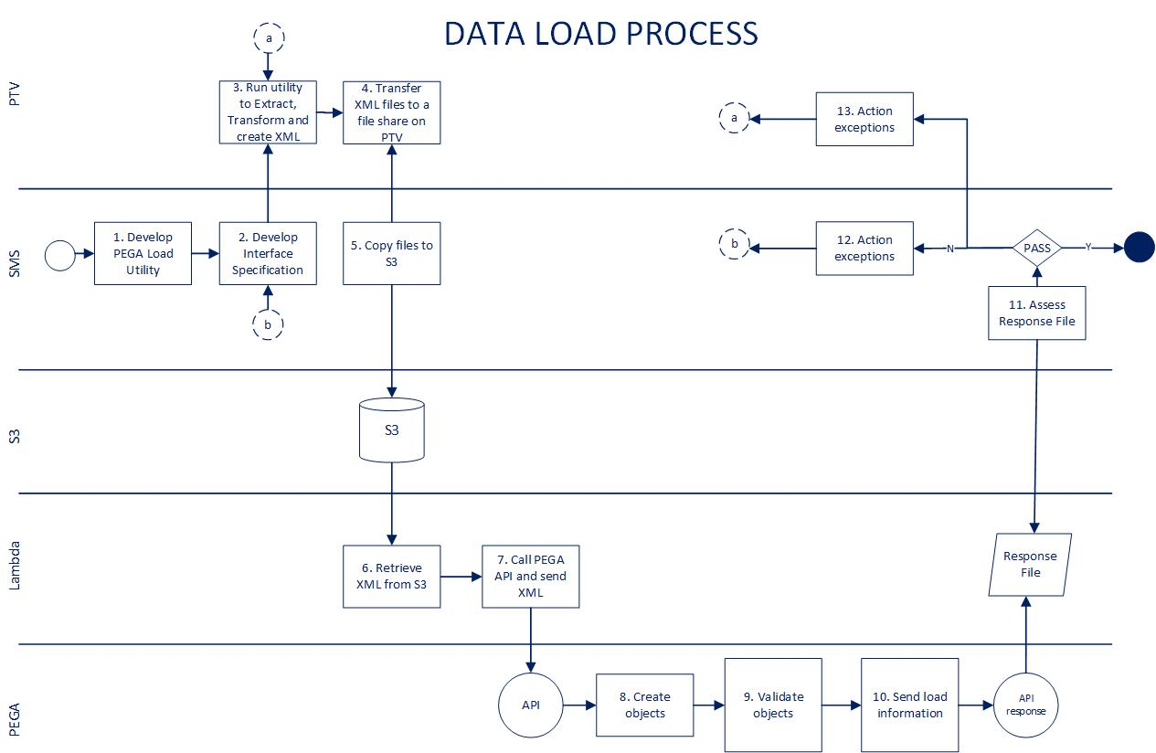

* Interface Specifications and Load Utility will be developed and tested by SMS, to reflect business requirements and rules.
* Using the Interface Specs, PTV will Extract and Transform the data and provide an XML.
* Using an automated load process, the XML files are loaded into PEGA via the relevant API and the outcome assessed against the success criteria.
* Audit and verification procedures will be executed to monitor the process for throughput, accuracy, context and timings.
* Validation of the load will be executed against the target application, and data migration metrics provided by PTV. Each iteration of testing through SIT, UAT and any field trials will provide an opportunity to assess the accuracy of the Load process and provide reports to satisfy the success criteria.
* Data verification will be undertaken by PTV and business experts will need to specify and undertake business level data verification scenarios.
* All Business Objects (BO) reports are converted to PDF format using a utility developed by SMS. These objects will be stored in the SPPS Report Object Store and their meta-data stored in the SPPS Reporting Database. Users will be able to view these object via the relevant case or global search screen in SPPS.
* The process will cater for a period of parallel processing between PASS and SPPS prior to go-live.

# Application Architecture

## Application Components

The diagram below shows a high level view of all application components of SPPS solution including user channels, process layer, integration layer and downstream systems.

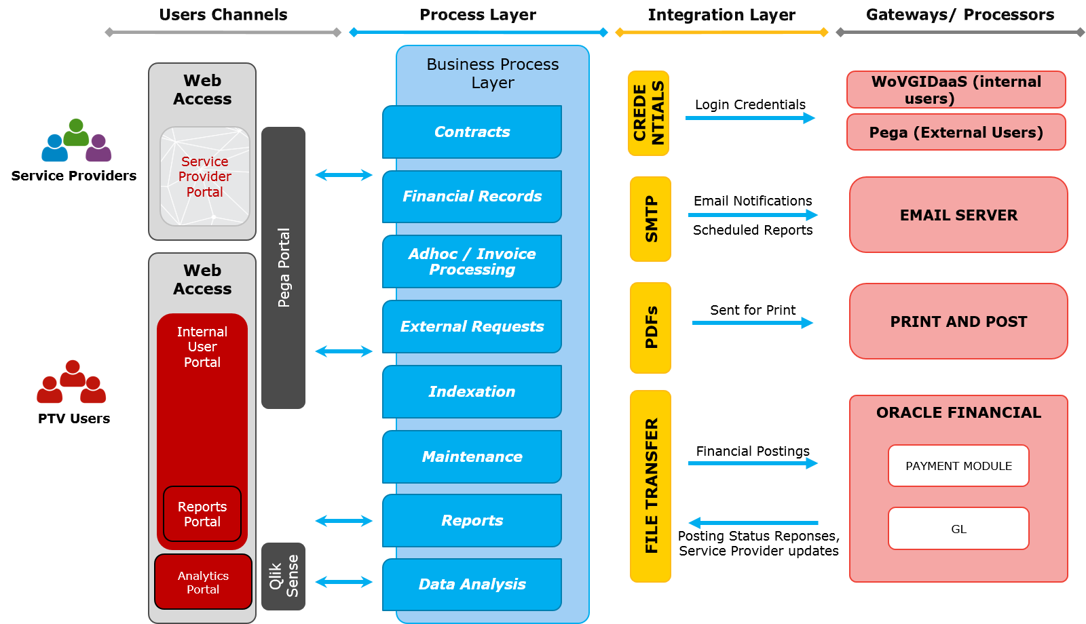

Figure 12: Application Components

The sections describe all application components at a high level.

### User Channels

|  |  |
| --- | --- |
| Service Provider Portal | This will be primary front end for PTV’s service providers. This will be a web based channel, securely accessible over standard web browser and will need an email-id and password to login.  Registration for all existing Services Providers will be performed as part of final deployment before Go Live and credentials will be shared with respective Service Providers. This portal will be built using Pega Portal capability and will also expose a self-service module will be for future registrations and reset-password functions. |
| Internal User Portal | This will be primary front end for PTV’s internal users of Finance and Pacman teams for all Service Provider’s payment related activities. This will be a web based channel, securely accessible over standard web browser and will be single-signed-on via WoVGIDaaS over SAML for internal PTV users.  Registration for all valid internal users will be performed as part of final deployment before Go Live to enable relevant PTV teams to access the new system. This portal will be built using Pega Portal capability. Internal users will not have facility of a self-service password for Change Password, and are expected to use normal means to change their domain password. |
| Report Portal | This will be primary front end for PTV’s internal users of Finance and Pacman teams to request and view Reports related to the Service Provider Payment System. The report portal will be embedded within the Internal User Portal, and appropriate access will be granted according to their role. |
| Analytics Portal | For PTV Finance and Pacman users who require the ability to perform deeper analysis or unstructured queries of data in the Service Provider Payment System, analytics capability will be provided by Qlik Sense in an Analytics Portal. |

### Process Layer

Once users login to respective portal, they are shown up relevant Landing/Home Page based upon their security authorisation profile.

Please refer to section 4.2 for more details on Business Processes implemented by the SPPS Solution.

### Integration Layer and Gateways

The SPPS solution is integrated to downstream systems in CenITex infrastructure or AWS infrastructure for various purposes. The table below captures these integrations at a high level. Please refer to section 6.2 for technical details around Integration Architecture.

|  |  |
| --- | --- |
| Login Credentials | The system will be integrated with CenITex hosted WoVGIDaaS service for validating login details for PTV users. Login credentials for external users will be validated from Pega database itself. |
| Email Notifications | The system will be integrated to an SMTP server (using AWS SES configurations) to send email notifications and scheduled reports. |
| Bulk Printing | The system will be integrated to the printer by implementing email-print, whereby the SPPS solution will send the document to be printed as an attachment to a pre-defined email address. Email received at this address from SPPS will be routed (by SafeQ) to the Finance Printer. |
| Payment processing and acknowledgement | The system will be integrated to Oracle Financial for disbursement of the payments calculated in SPPS and will receive acknowledgement from Oracle for success/failure of these payments. |
| Reporting Data | The system will be integrated to a relational database, which will act as a downstream integration point for exposing contract, payment and service provider data in a normalised form for use in static report generation, unstructured reports/ad-hoc queries and analytics. |
| Report Generation | The system will be integrated to a reporting service that can generate reports on-demand for both user-requested and workflow-initiated cases from normalised data |
| Global Report Retrieval | The system will be integrated to a report object repository that contains reports which have been migrated from the legacy PASS system as well as reports generated by SPPS. This enables a user to search globally for reports and correspondences that span both systems. It also provides a global search mechanism for finding and retrieving report objects that span beyond Contract, Payment and Service Provider boundaries. |

## Integration Architecture

The diagram below highlights all the integration touch points between different components of the solution. The diagram below is not an indication of the physical architecture and it shown the instances of various parts of the solution. Please refer Infrastructure Architecture section 7.2 for physical architecture view.

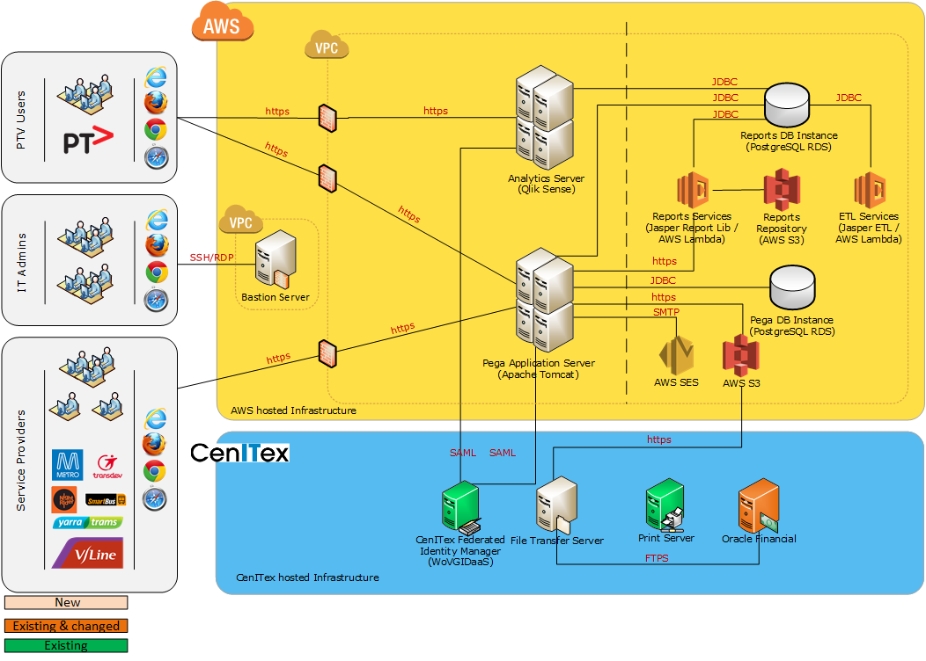

Figure 13: Logical Architecture

The following sections capture all integration interfaces for SPPS solution:

### Pega and Qlik Sense via CenITex Federated Identity Manager

|  |  |
| --- | --- |
| From | Pega |
| To | CenITex Federated Identity Manager (WoVGIDaaS) |
| Payload | SAML assertion |
| Description | Users who login into Pega will be authenticated from the CenITex Federated Identity Manager using SAML. |
| Operation | * PTV users will open the SPPS solution via an intranet link * The user will be redirected to the identity manager, where they will be authenticated via Single Sign On (no login screen) and redirected back to Pega to commence their session. * After a period of inactivity, the user will be automatically logged out of Pega. |
| Synch/Async | Sync |
| Frequency | Every login request |
| Typical Payload Size | Small (< 1M) |
| Protocol | SAML |

|  |  |
| --- | --- |
| From | Qlik Sense |
| To | CenITex Federated Identity Manager (WoVGIDaaS) |
| Payload | SAML assertion |
| Description | Users who login into Qlik Sense will be authenticated from the CenITex Federated Identity Manager using SAML. |
| Operation | * PTV users will click a link from SPPS solution (Pega) * The user will be redirected to the identity manager, where they will be authenticated via Single Sign On (no login screen) and redirected Qlik Sense to commence their session. * After a period of inactivity, the user will be automatically logged out of Qlik Sense. |
| Synch/Async | Sync |
| Frequency | Every login request |
| Typical Payload Size | Small (< 1M) |
| Protocol | SAML |

The diagram below explicitly shows this integration pattern.

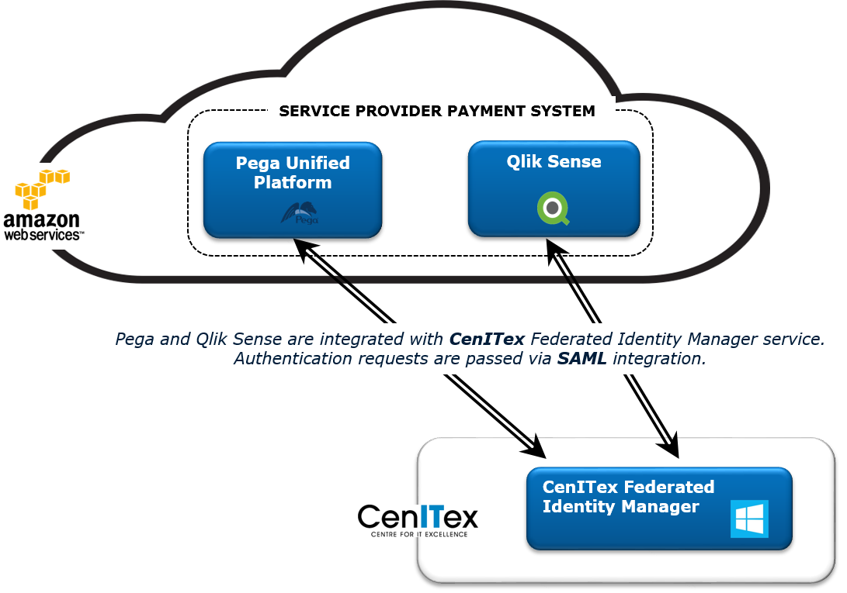

Figure 14: Integration with WoVGIDaaS

### Pega and Oracle Financials

|  |  |
| --- | --- |
| From | Pega |
| To | Oracle Financials |
| Payload | Payment File |
| Description | SPPS solution in Pega will produce disbursed Payment Files and transfer to a folder in AWS S3 bucket.  A server in CenITex will host a scheduled File Transfer Utility to pull files from S3 bucket using REST/HTTPS and put into a network share (exposed via FTPS), which can be accessed by Oracle Financial.  The S3 bucket will allow external connectivity from whitelisted IP addresses only.  The file will be in a specific format (*refer DOC-08-82663 -- Oracle Financials Accounts Payable Interface Format.docx*). This is the same format as used by PASS. |
| Operation | * This is a system to system integration. * The File Transfer Utility will be written using Powershell scripts, which call the AWS Command Line Interface securely transport files from AWS to CenITex. * The file will be encrypted (using AES-256) prior to being placed in the S3 bucket for transmission. |
| Synch/Async | Async |
| Frequency | Interface polls at a 30 minute interval. One or more files may be produced daily on a variable schedule. |
| Typical Payload Size | Small (<1M) |
| Protocol | REST over HTTPS |

|  |  |
| --- | --- |
| From | Oracle Financials |
| To | Pega |
| Payload | Vendor File, Invoice Acknowledgement File, Disbursement Status File |
| Description | Oracle Financials will produce a Vendor File will be used by Pega to update Vendor details, as well as an Invoice Acknowledgement File and a Disbursement Status File, for Pega to update Invoices with appropriate failure/success statuses of invoice lodgement and payment.  A server in CenITex will host a scheduled File Transfer Utility to push files to an S3 bucket using REST/HTTPS. This utility will read file from a network share (exposed via FTPS), which can be accessed by Oracle Financial.  The S3 bucket will allow external connectivity from whitelisted IP addresses only.  The Vendor Details File will be in a specific format (*refer DOC-08-82663 -- Oracle Financials Accounts Payable Interface Format.docx*). This is the same format as used by PASS.  The Invoice Acknowledgement File and Disbursement Status File share a common format (Refer to document SA-RD15) |
| Operation | * SPPS code and configurations will be IP of PTV and stored in PTV repository (bitbucket Git). * The File Transfer Utility will be written using Powershell scripts, which call the AWS Command Line Interface securely transport files from CenITex to AWS. The file will be encrypted (Using AES-256) by Oracle Financials prior to being placed in the network share, and will be decrypted after being consumed from the S3 transmission bucket. |
| Synch/Async | Sync |
| Frequency | Interface polls at a 30 minute interval. One or more of each file may be produced daily on a variable schedule. |
| Typical Payload Size | Small (< 1M) |
| Protocol | REST over HTTPS |

The diagram below explicitly shows this integration pattern.

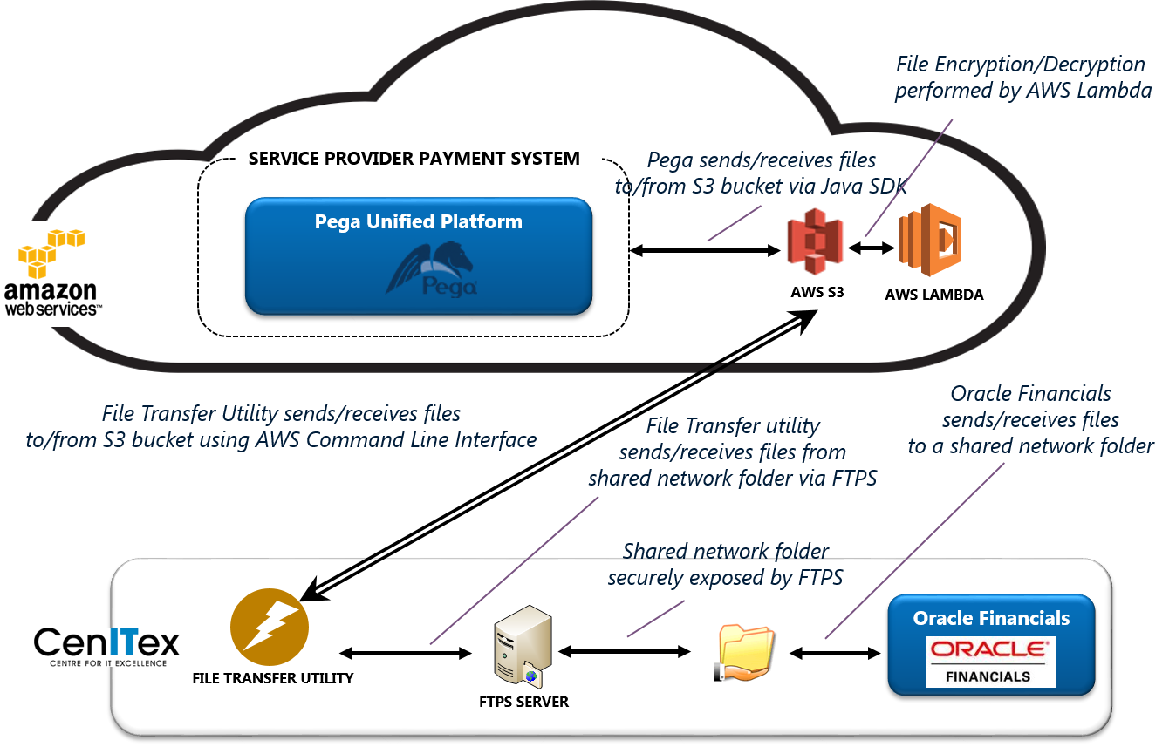

Figure 15: Integration with Oracle Financials

### Pega and Email Service (AWS SES)

|  |  |
| --- | --- |
| From | Pega |
| To | Email Service (AWS SES) |
| Payload | Email Notification |
| Description | SPPS solution will use AWS SES service to send out email notification from Pega workflows. |
| Operation | * This is a system to system integration and the solution will use the Simple Mail Transfer Protocol (SMTP) interface to send emails via AWS SES. * All email attachments sent externally to Service Providers will be password protected.   Email sent from Pega will be of frequency and volume that conform to SES transaction-per-second and transaction-per-day thresholds (currently limited to 50000 emails per 24 hours at a maximum rate of 14TPS. Note, this may be raised upon request). |
| Synch/Async | Sync, Async |
| Frequency | Regular business day ~ 10-20, Month end business day ~500-1000. |
| Typical Payload Size | 1mb – 5mb |
| Protocol | SMTP (STARTTLS) |

The diagram below explicitly shows this integration pattern.

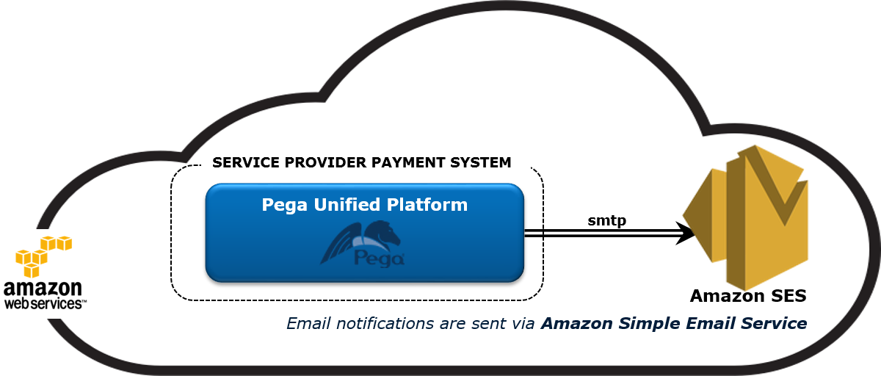

Figure 16: Integration with Email

### Pega and Printer (Via Email Service)

|  |  |
| --- | --- |
| From | Pega |
| To | Finance Printer |
| Payload | Payment Advice |
| Description | SPPS solution in Pega will produce Payment Advices and send via Email (using the AWS SES service) to an existing PTV email address that is routed to the appropriate PTV printer, where the attachment will be queued for printing.  The between Amazon SES and the PTV (CenITex) mail server is encrypted using STARTTLS for the channel handshake. |
| Operation | * This is a system to system integration. * Printing will leverage the existing Konica Minolta SafeQ Print Utility, with policy set to route email from SPPS to the Finance Printer.   Email sent from Pega will be of frequency and volume that conform to SES transaction-per-second and transaction-per-day thresholds (currently limited to 50000 emails per 24 hours at a maximum rate of 14TPS. Note, this may be raised upon request). |
| Synch/Async | Async |
| Frequency | Regular business day ~ 10-20, Month end business day ~500-1000. |
| Typical Payload Size | 1mb – 5mb |
| Protocol | SMTP (STARTTLS) |

The diagram below explicitly shows this integration pattern.

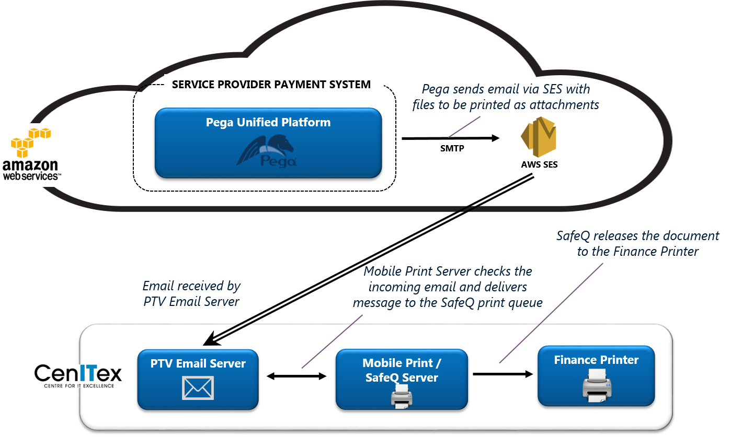

Figure 17: Integration with Printer

### Pega, BIX and Reporting Database

|  |  |
| --- | --- |
| From | Pega |
| To | Reporting Database |
| Payload | Contract, Payment and Service Provider information |
| Description | Pega stores case data in a proprietary BLOB format. In order to perform reporting or other interactions on Pega case data, it must be converted to a suitable normalised format and enriched with supporting data that is not stored as part of the case |
| Operation | * The Pega BIX program will be triggered on a schedule * The BIX export will send all case information since the last execution to a staging table in the reporting database * Jasper ETL will normalise each case into a relational structure, and enrich the case data with all supporting master data and reference data to be full self-described |
| Synch/Async | Async |
| Frequency | Hourly |
| Typical Payload Size | Med (1-5M) |
| Protocol | JDBC |

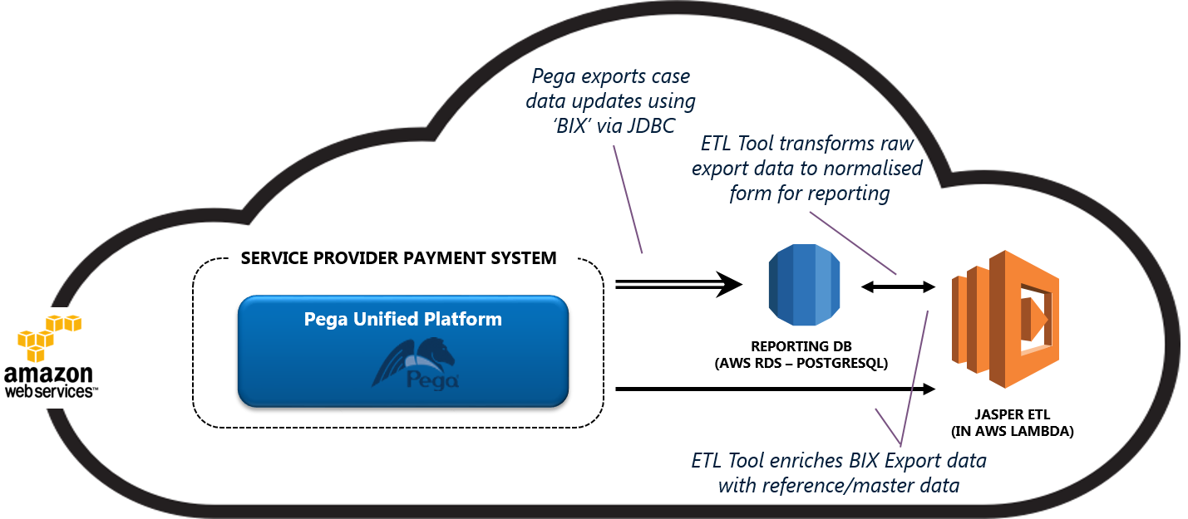

Figure 17: Integration with BIX and Reporting Database

### Pega and Report Generator

|  |  |
| --- | --- |
| From | Pega |
| To | Report Generator |
| Payload | JSON payload |
| Description | When a report is required to be generated from Pega (either as a user-initiated request, or Pega-initiated process), a request will be sent to the Report Generator Service. The reporting database will be queried, the results rendered, and a report file returned to Pega. |
| Operation | * The Report Generator consists of a package of report templates and a java library (Jasper Reports Library) deployed into an AWS Lambda function * Each request from Pega will initiate an instance of the Lambda function * Requests will invoke a query against the reporting database to retrieve the report data * Report data will be rendered according to the report template * Report file content will be returned to Pega |
| Synch/Async | Sync |
| Frequency | User Requested ZZZ per day  Pega initiated XXX per day, YYY month end |
| Typical Payload Size | Small (< 1M) |
| Protocol | REST over HTTPS |

The diagram below explicitly shows this integration pattern.

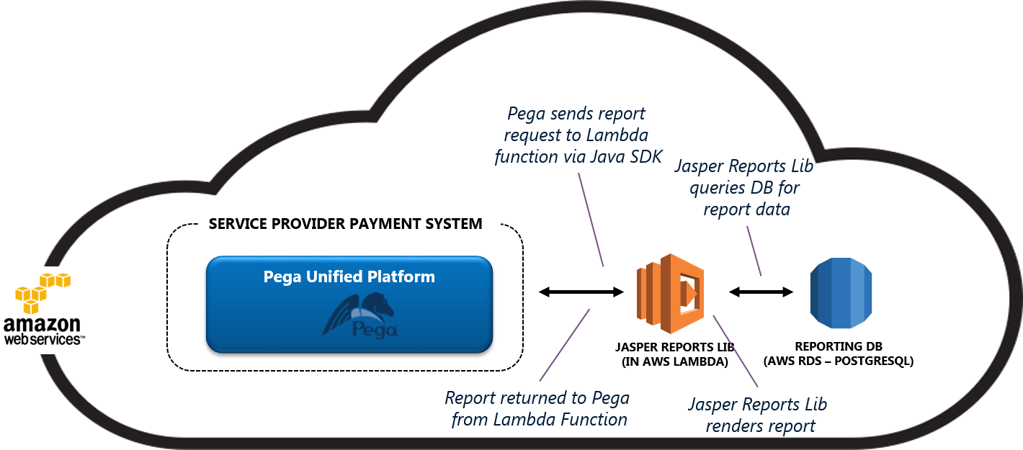

Figure 15: Integration with Report Generator

### Pega and Report Object Repository

|  |  |
| --- | --- |
| From | Pega |
| To | Report Object Repository |
| Payload | Report attachment data |
| Description | In order to allow a user to search globally for reports and correspondences that span both reports generated in Pega and those migrated from PASS, report objects created will regularly be exported from Pega to the report object repository, where they will be indexed in the Reporting Database and stored in S3. |
| Operation | * The Pega BIX program will be triggered on a schedule * The BIX export will send all attachment to a staging area in S3. * A lambda function will parse the Export file, store the file object in S3 and save the metadata (including the S3 location) to an index table in the Reporting Database. |
| Synch/Async | Async |
| Frequency | Hourly |
| Typical Payload Size | Small (<1M) |
| Protocol | REST/HTTPS |

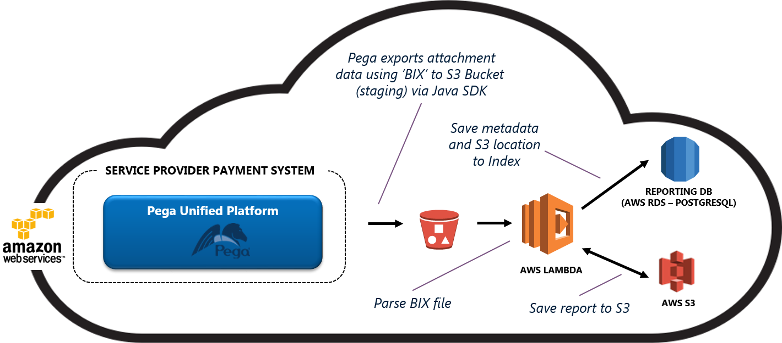

Figure 17: Integration with Pega and the Report Object Repository (Upload)

|  |  |
| --- | --- |
| From | Pega |
| To | Report Object Repository |
| Payload | Report files |
| Description | When a user wants to perform a search to retrieve report objects that span beyond Contract, Payment and Service Provider boundaries, they can perform a ‘global’ search on the report object repository index to find the location of the required report in S3.  The search is exposed as a service and is integrated into Pega.  Searching this repository will provide a consistent search across objects created in Pega and the legacy PASS system. |
| Operation | * A user will execute a search from within Pega, specifying criteria to search on. * Lambda will perform a search on the index in the (Reporting DB) for all reports that match the criteria * A list of matching files will be presented to the user * If the user wishes to download them, they will be drawn from S3. |
| Synch/Async | Synch |
| Typical Payload Size | Small (<1M) |
| Protocol | REST/HTTPS |

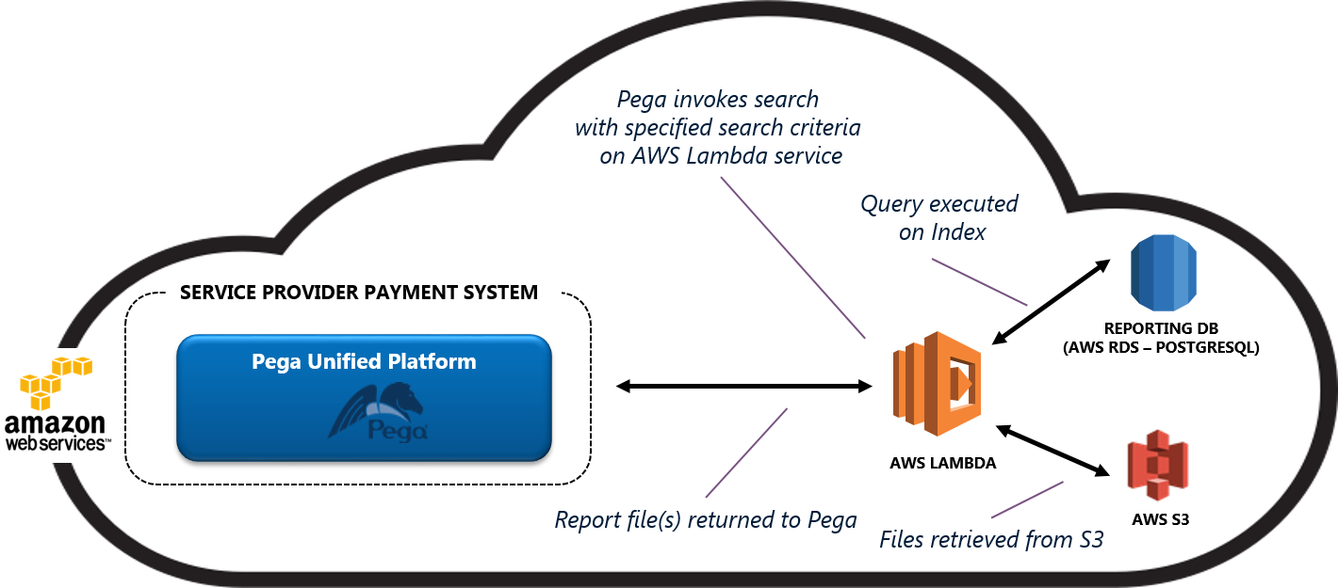

Figure 17: Integration with Pega and the Report Object Repository (Retrieval)

## Presentation Architecture

The SPPS solution is built on Commercial-off-the-shelf products Pega PRPC, Qlik Sense and JasperReports for the presentation layer.

Pega will expose a portal for PTV Internal and External users (Service Providers); and this portal will be used as an interface for pre-defined SPPS reports. Deeper analysis into SPPS data can be performed by PTV users in the Analytics Portal.

The diagram below shows a high level architecture for Presentation Layer.

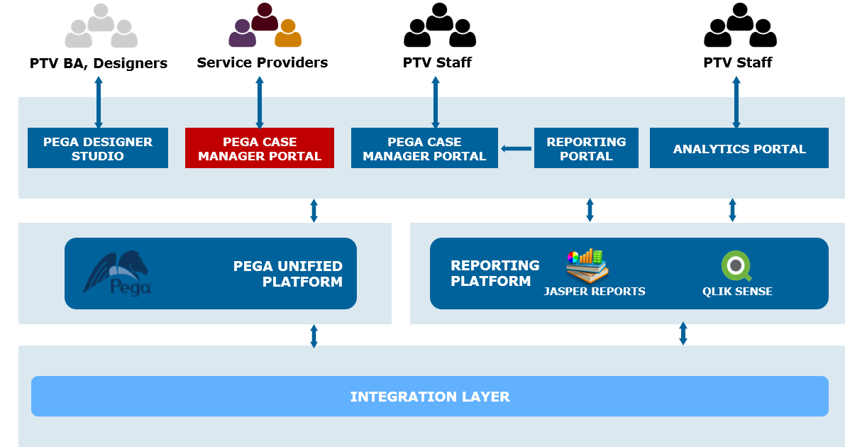

Figure 18: Presentation Architecture

### Pega Case Manager Portal

Pega Case Manager Portal provides users (who are sometimes called caseworkers) with a standard user interface for:

* Creating, viewing, and working on cases
* Displaying unresolved cases, their subcases, and a case's open assignments
* Displaying associated content, users, roles, and subjects
* Monitoring work group status, goals, and deadlines
* Generating work management reports

SPPS solution will have Case Manager Portal configured for PTV users and external users to provide them a user interface relevant to their user role.

### Pega Designer Studio

Pega Designer Studio is a web-based integrated development environment that you use to build Pega applications. Designer Studio provides access to tools, wizards, reports, and other features for application developers and designers.

This will be used by OPSM implementation team to develop SPPS solution.

### Reporting Portal

The Reporting Portal is a primary interface for PTV staff to access / view SPPS reports, including preconfigured static reports and migrated historical reports, as well as executing ad-hoc queries to obtain deeper (yet unstructured) insight into SPPS data. The functionality that comprises the reporting portal is embedded in the Pega Case Manager Portal to provide a single point of user interaction with the solution.

### Analytics Portal

The Analytics Portal is an interface for PTV staff to obtain deeper insight into SPPS data. The interface provides a mechanism for analysing contract and payment data for creating ad-hoc queries and reports. By providing a secure means for analysis within the solution, data leakage through export can be minimised.

# Technology Architecture

SPPS solution is based primarily on the Amazon Web Services cloud environment with additional third party products and custom software that provides enhanced security, logging and monitoring. On-premise virtualised environments, hosted by CenITex, will facilitate connectivity between the SPPS cloud environment, and existing/legacy PTV systems. Each environment will be architected to achieve the following outcomes:

* **Production / Pre Production (Production Support) Environment** – Both the production and pre-production environments will be identical in architecture and sizing to enable like-for-like testing, before changes are deployed to Production. They are designed to be scalable, highly available, secure, and quick to provision and recover. The physical architecture of the production and pre-production environments is described in detail in section 7.2.1 and 7.2.2, respectively.
* **Non-Production** **Environments** – The architecture and services used in the development and test environments are similar to the production environment, but scaled back in terms of resilience, performance and availability to enable full functionality at a reduced cost. The physical architecture of the test and development environments is described in detail in section 7.2.3 and 7.2.4, respectively.
* **DevOps Environment** – Technically not a standalone environment, the DevOps environment provides shared services for the above environments. By connecting the environment (through VPC peering) to the other environments, it can act as a centralised provider of access (via bastion servers), monitoring (for incident ticketing), user management (for windows/linux server access), time synchronisation, continuous integration and automated testing.

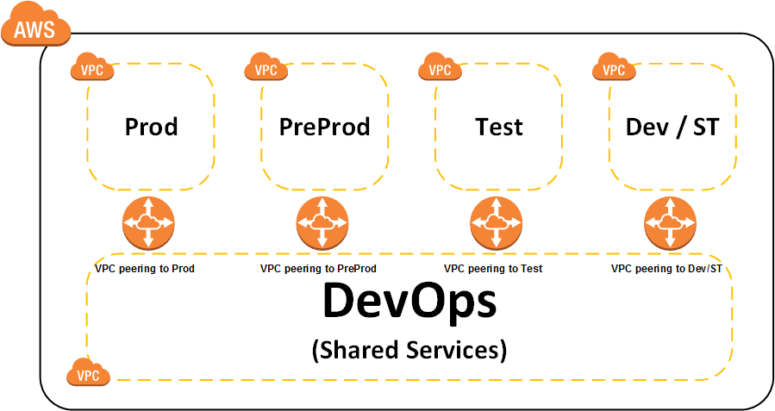

Figure 21: Shared Services Provided by the Connected DevOps Environment

The physical architecture of the DevOps environment is described in detail in section 7.2.5

The sizing principal of the cloud environments is to use server instances that provide adequate capacity, without over-provisioning. The environment will be configured to make use of AWS auto scaling to maintain application availability, and can automatically scale capacity up or down according to predefined conditions.

The sizing estimates for the Pega components of the solution consider outputs from the Pega Hardware Platform Sizing Estimation technique. The platform sizing will be refined after the performance testing phase of the project based upon the results from performance test.

## Environments

There will be three main development streams for OPSM project and following Environments have been identified to be used in different phases between development and final deployment.

* Pega Application Development stream
* Data Migration stream
* Reporting Solution stream

The diagram below shows a high level view of all the environments needed to support the development, test and production platforms. Please note that below diagram only represents the environments with respective components required by different streams, there will be sharing of environments where common components are used.



Figure 19: Environments

### Hardware (Virtual Server) Specifications

This section captures details of the hardware specifications for production, non-production and DevOps AWS EC2 instances and CenITex virtual machines planned for the SPPS solution.

A blend of AWS EC2 instance types are utilised in the SPPS solution, tailored to the specific use-case and performance requirements of the components deployed upon them. The AWS EC2 instances required are described as follows:

| Server Category  (instance type) |  | Number of EC2 Instances | | | | | | | |
| --- | --- | --- | --- | --- | --- | --- | --- | --- | --- |
| Dev | ST | SIT | UAT | TRN | Pre Prod | Prod | DevOps | Total |
| **Pega App Servers**  RHEL on m4.xlarge |  |  |  |  |  | 2 | 2 |  | **4** |
| RHEL on m4.large | 1 | 1 | 1 | 1 | 1 |  |  |  | **5** |
| **Qlik Sense Server**  Windows on r3.xlarge |  | |  | | | 2 | 2 |  | **4** |
| Windows on r3.large | 2 | | 2 | | |  |  |  | **4** |
| **Sophos Swarm UTM Servers**  SUSE Linux on c3.large |  | |  | | | 2 | 2 |  | **4** |
| SUSE Linux on m3.medium | 2 | | 2 | | |  |  |  | **4** |
| **Sophos Queen UTM Servers**  SUSE Linux on t2.small | 2 | | 2 | | | 2 | 2 |  | **8** |
| **Bastion Servers**  Windows on t2.medium |  |  |  |  |  |  |  | 1 | **1** |
| RHEL on t2.small |  |  |  |  |  |  |  | 1 | **1** |
| **Test Automation Server**  Windows on t2.small |  |  |  |  |  |  |  | 1 | **1** |
| **Continuous Integration Server / Time Source Server**  RHEL on t2.medium |  |  |  |  |  |  |  | 1 | **1** |
| **Monitoring Agent Servers**  RHEL on t2.medium |  |  |  |  |  |  |  | 2 | **2** |

The specification for these instance classes, and the storage provisioned to them, are described below:

T2 - General Purpose:

|  |  |  |  |  |
| --- | --- | --- | --- | --- |
| Model | vCPU | Mem (GB) |  | EBS Storage |
| t2.small | 1 | 2 |  | 60GB (SSD) |
| t2.medium | 2 | 4 |  | 60GB (SSD) |

M1/M3/M4 – General Purpose:

|  |  |  |  |  |
| --- | --- | --- | --- | --- |
| Model | vCPU | Mem (GB) |  | EBS Storage |
| m1.small | 1 | 1.7 |  | 60GB (SSD) |
| m3.medium | 1 | 3.75 |  | 60GB (SSD) |
| m4.large | 2 | 8 |  | 60GB (SSD) |
| m4.xlarge | 4 | 16 |  | 60GB (SSD) |

C3 – Compute Optimised:

|  |  |  |  |  |
| --- | --- | --- | --- | --- |
| Model | vCPU | Mem (GB) |  | EBS Storage |
| c3.large | 2 | 3.75 |  | 60GB (SSD) |

R3 – Memory Optimised:

|  |  |  |  |  |
| --- | --- | --- | --- | --- |
| Model | vCPU | Mem (GB) |  | EBS Storage |
| r3.large | 2 | 15.25 |  | 60GB (SSD) |
| r3.xlarge | 4 | 30.5 |  | 60GB (SSD) |

The on-premise servers to be hosted by CenITex are described as follows:

| Server Category  (instance type) |  | Number of Virtual Machine Instances | | | | | | |
| --- | --- | --- | --- | --- | --- | --- | --- | --- |
| Dev | ST | SIT | UAT | TRN | Pre Prod | Prod | Total |
| **File Transfer Utility Server**  Windows on CenITex.medium | 1 | 1 | | | | | 1 | **3** |
| **FTPS Server**  Windows on CenITex.medium | 1 | 1 | | | | | 1 | **3** |

Only one class of on-premise server will be utlilised:

|  |  |  |  |  |
| --- | --- | --- | --- | --- |
| Model | vCPU | Mem (GB) |  | Storage (GB) |
| CenITex.Medium | 2 | 4 |  | 10 |

### AWS Service Specifications

A number of AWS services will be utilised in the SPPS solution, tailored to the specific use-case and performance requirements of the components deployed upon them. The AWS services that have environment-specific sizing requirements are described as follows:

| Service Category  (instance type) |  | Number of Instances | | | | | | |
| --- | --- | --- | --- | --- | --- | --- | --- | --- |
| Dev | ST | SIT | UAT | TRN | Pre Prod | Prod | Total |
| **RDS (Pega)**  PostgreSQL on db.r3.xlarge (Multi-AZ) |  |  |  |  |  | 1 | 1 | **2** |
| PostgreSQL on db.r3.large (Single-AZ) | 1 | 1 | 1 | 1 | 1 |  |  | **5** |
| **RDS (Reporting)**  PostgreSQL on db.r3.large (Multi-AZ) |  |  |  |  |  | 1 | 1 | **2** |
| PostgreSQL on db.r3.large (Single-AZ) | 1 | 1 | 1 | 1 | 1 |  |  | **5** |
| **ElasticSearch (Logging/Monitoring)**  t2.medium.elasticsearch | 2 | | | | | 2 | 2 | **6** |
| **Directory Service (Simple AD)**  Small |  | | | | |  | 1 | **1** |

The table below captures additional AWS services required to support the SPPS solution, which do not require sizing/provisioning.

| Service Name |
| --- |
| Virtual Private Cloud (VPC) |
| Simple Storage Service (S3) |
| S3 VPC Endpoint |
| Lambda |
| Cloud Formation |
| Simple Email Service (SES) |
| Route53 |
| Cloudwatch |
| CloudTrail |
| Identity & Access Management (IAM) |
| Elastic Load Balancing (ELB) |
| Key Management Service (KMS) |

### Software Specifications

The table below captures the software inventory required for SPPS solution

| Name | Version | Vendor | Licence model | No of licence Units |
| --- | --- | --- | --- | --- |
| Pega PRPC | 7.2.1 | Pegasystems | Pega Perpetual Licence | 100 users (concurrent not named) |
| Pega BIX | 7.2.1 | Pegasystems |
| Sophos Server Protection | Server Central Protection Standard | Sophos | Per server licence | 25 |
| Sophos UTM | 9 | Sophos | Per server licence | 16 |
| Qlik Sense Enterprise | 3.1 | Qlik | Named User  Variable User Tokens | 20 named users  30 variable user tokens |
| JasperReports Library | 6.3.1 | TIBCO Software | Licenced as Jasper Reports Reporting Edition with ETL Add-on. | 1 |
| JasperSoft ETL | 6.2.1 | TIBCO Software |
| Microsoft Internet Information Services | 8.5 | Microsoft | N/A - Included in Windows Server | N/A |
| Apache Tomcat | 8.5.5 | Apache | N/A – Included in RHES | N/A |
| AWS CLI | 1.10.38 | Amazon Web Services | N/A - Included in AWS | N/A |
| AWS Java SDK | 1.11.36 | Amazon Web Services | N/A - Included in AWS | N/A |
| NSClient  (Monitoring Client/Agent) | 0.4.4 | NSClient.org | Free / Open Source *  Licensed under GNU GPL:  <https://docs.nsclient.org/license.html> | N/A |
| Exp4j #  (Pega ruleset expression engine) | 0.4.7 | http://www.objecthunter.net/exp4j/ | Free / Open Source  Licensed under Apache 2.0:  <http://www.objecthunter.net/exp4j/license.html> | N/A |
| PGAdmin IV (PostgreSQL GUI) | 1.1 | PGAdmin | Free / Open Source *  Licensed under PostgreSQL licence:  <https://www.pgadmin.org/licence.php#postgresql> | N/A |
| Putty (Bastion host for windows) | 0.67 | Simon Tatham | Free / Open Source *  Licensed under MIT Licence:  <http://www.chiark.greenend.org.uk/~sgtatham/putty/licence.html> | N/A |
| Selenium ^  (Test Automation) | 3.0 | SeleniumHQ | Free / Open Source *  Licensed under Apache 2.0:  <http://docs.seleniumhq.org/about/license.jsp> | N/A |
| Jenkins ^  (Continuous Integration) | 2.25 | Jenkins.io | Free / Open Source *  Licensed under MIT Licence:  <https://jenkins.io/license/> | N/A |
| Cucumber ^  (Automation Test Scenarios) | 1.3.15 | Cucumber Ltd | Free / Open Source *  Licensed under MIT Licence:  <https://github.com/cucumber/cucumber/blob/master/LICENSE> | N/A |

* License reviewed, and no restrictions identified that would limit use for SPPS

^ For additional details on implementation of these tools, refer to the following wiki page: <https://publictransportvic.atlassian.net/wiki/display/OPSMR1/Automation+Testing>

# Component will not preclude future upgrades of Pega. Any future Java version compatibility issues may be managed by recompile, if required.

## Infrastructure Architecture

The SPPS solution consists of a fault tolerant pool of servers, network infrastructure and communications services based in AWS, orchestrated to provide continuous, highly available, stable operation of the solution.

The SPPS production environment will be spread across two highly resilient availability zones in the Sydney region. The design follows the same resiliency principle and proposes each level with two devices across two AWS Availability Zones. Failover is automatic between devices and availability zones and load is balanced across servers. The solution is designed at all levels to route around any failed device or server and will automatically spin up replacement servers/services upon failure. The system is able to scale up/down without manual intervention in response to high load.

The solution follows a minimum permissions model along with threat management devices at the perimeter/gateway, security group isolation for solution components and fine-grained access control using the AWS Identity and Access Management security framework. Access is restricted at every layer of the design to allow only the minimum necessary network traffic. Communication is restricted by whitelisting access between servers/services to support application and processing requirements only. Administrative access to the AWS environment is via bastion host from a restricted IP range for a select group of administrative users which are managed in AWS Directory Service.

AWS Cloud Formation is used to create a blueprint from which environments and servers can be created rapidly and automatically to ensure that each of the environments is consistent and re-creatable. All resources, including network, security, authentication, DNS, and monitoring, are created from this blueprint. The user facing website will be created using the blueprint on a hardened server image to ensure that the solution meets or exceeds PTV security requirements and provides a consistent, automatically scaling, self-healing and manageable environment.

Infrastructure outside the AWS platform required for integrating with existing PTV systems will be hosted within the CenITex network on virtualised highly-available servers.

### Production



Figure 20: Production Physical Architecture – AWS

The production environment has been designed in a manner that provides security, availability, scalability, performance and reliability. Highlights of the production environment are as follows:

* High availability across all components by deploying components across multiple availability zones (With Elastic Load Balancer for load-balanced EC2 instances, and Multi-AZ configuration for RDS databases)
* Auto-scaled EC2 instances to provide high availability, and further scaling (if performance thresholds exceeded).
* Use of highly available and durable AWS services (eg, S3, Lambda, SES, ElasticSearch)
* All application servers grouped by function and are hosted in separate, private subnets
* Each component of the solution deployed/provisioned in isolated in separate security groups, where communications between security groups is explicitly granted by whitelist (ip, protocol, port) only.
* Entry for application traffic is secured via a single gateway (UTM) in a public subnet, where threat management activities can be performed prior to allowing traffic internal to the private subnets.

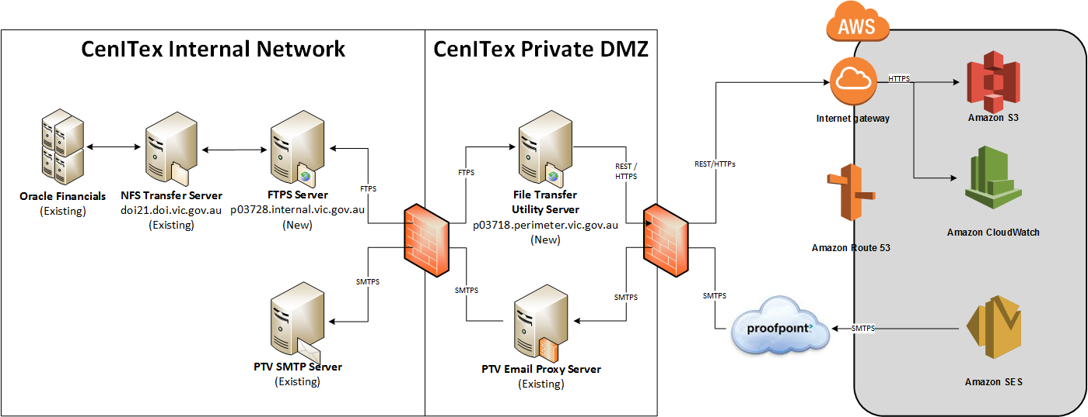

Figure 21: Production Physical Architecture – CenITex

The production environment has been designed in a manner that provides security and availability. Highlights of the production environment are as follows:

* File Transfer Server and FTPS server hosted virtual machines that can leverage vMotion (or equivalent) transfer to alternate hosts in the event of underlying physical host failure.
* Perimeter DMZ to provide isolation layer between the internet and CenITex internal network, with firewalls at each boundary
* Scanning of emails for threats prior to receipt by PTV SMTP Server/Proxy.
* Email sent from Amazon SES to proofpoint, and from proofpoint to the PTV SMTP server is sent using a secured channel (STARTTLS)

### Pre-Production (Production Support)



Figure 22: Pre-Production Physical Architecture – AWS

The topology, specification and configuration of the pre-production environment is as per production to ensure provisioning, testing and support and operation are consistent with the production environment.

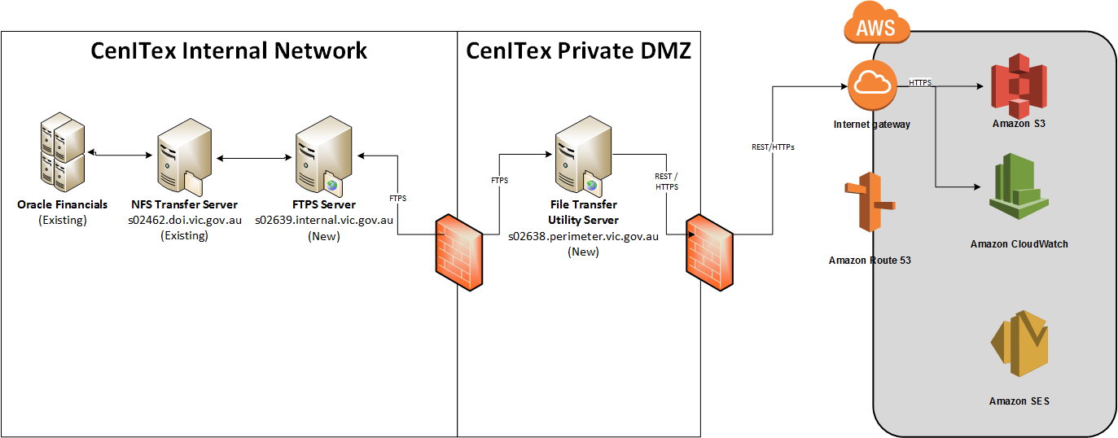

Figure 23: Pre-Production Physical Architecture – CenITex

### Systems Integration Test / User Acceptance Test / Training



Figure 24: Test Physical Architecture – AWS

The test environment has been designed in a manner that provides similar functionality to production, while reducing server specification and redundancy / availability. The environment leverages ‘on-demand’ EC2 server instances, which can be powered down (and not charged for) when not in use.

The test environment has been designed so that core infrastructure components (ie UTM gateway, etc) are implemented once, and application components (ie Pega, databases, etc) are provisioned for each class of testing (ie, SIT, UAT and Training).



Figure 25: Test Physical Architecture – CenITex

### Development / System Test



Figure 26: Development Physical Architecture – AWS

The development environment has been designed in a manner that provides similar functionality to production, while reducing server specification and redundancy / availability. The environment leverages ‘on-demand’ EC2 server instances, which can be powered down (and not charged for) when not in use.

The development environment has been designed so that core infrastructure components (ie UTM gateway, etc) are implemented once, and application components (ie Pega, databases, etc) are provisioned for development and system testing.

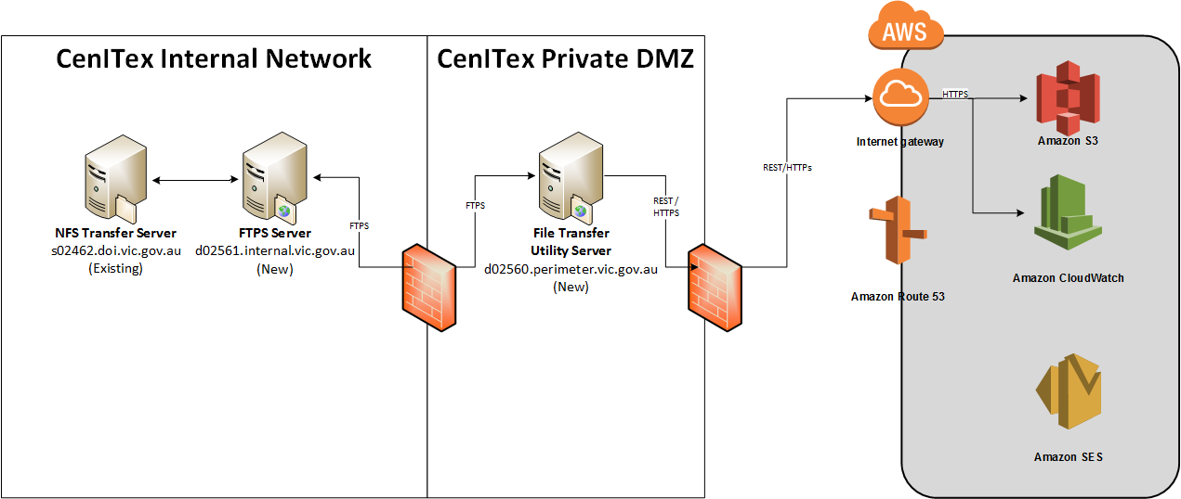

Figure 27: Development Physical Architecture – CenITex

### DevOps



Figure 28: DevOps Physical Architecture – AWS

The DevOps environment has been designed in a highly-available manner that provides security and common supporting infrastructure to all the environments. Highlights of the DevOps environment are as follows:

* Single point of entry into the solution for management activities/interfaces, with access restricted to PTV network
* Supports infrastructure common to all environments, namely bastion hosts, Monitoring Agent, Directory Services, Time synchronisation server, Continuous Integration and Test Automation servers
* Auto-scaled EC2 instances to provide high availability
* Components deployed/provisioned in isolated in separate security groups, where communications between security groups is explicitly granted by whitelist (ip, protocol, port) only.

## Operations Architecture

The following section describes how the solution addresses key operational aspects in accordance with the non-functional requirements.

### Monitoring

The solution will monitor the environment at two levels:

* **AWS monitoring** of Cloud infrastructure and services – Solution will use the CloudWatch monitoring capability of AWS in conjunction with AWS ElasticSearch to monitor the infrastructure for issues.
* **NSClient Monitoring Probe** – In addition to the AWS monitoring tools redundant EC2 instances with NSClient will be installed in the DevOps VPC to monitor the infrastructure at operating system level. This tool can monitor individual services for failure or high load etc., and is configured to generate an incident to an incident management system (eg Nagios XI used by SMS for managed services) if a critical problem is detected. This tool has the added benefit of facilitating collection of more detailed OS level metrics that provide crucial information for reporting, continuous improvement and capacity planning.

### Logging

Within the SPPS solution, there are a multitude of logs produced that individually identify the health, status, activity and access of various components of the solution. These include application logs, operating system logs, AWS services logs, as well as networking, security, amongst others.

Consolidating these log files into a centralised location (AWS ElasticSearch) will allow for better flexibility around policy (ie, retention) and management (event correlation, visualisation and further action).

Logs will be collated as follows:

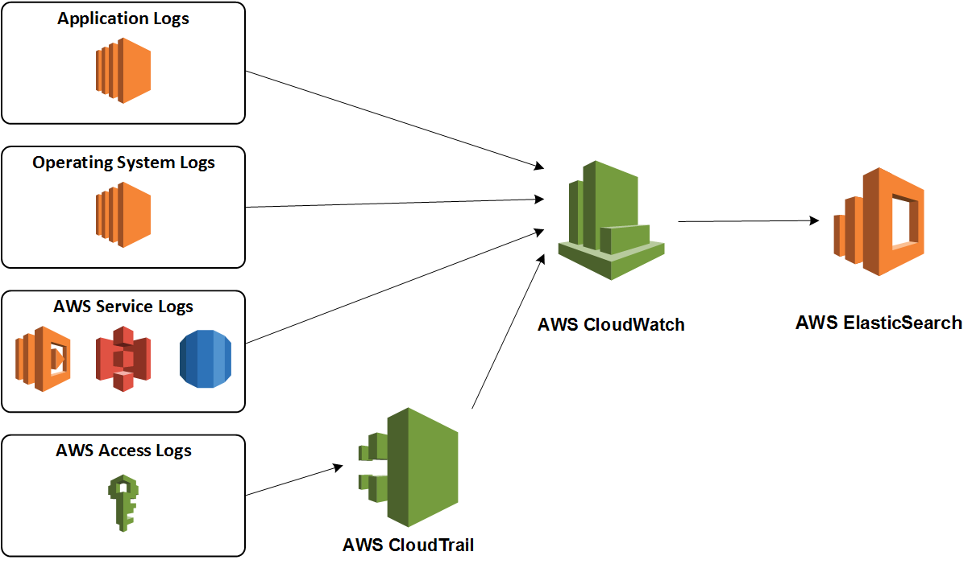

Figure 29: Consolidated Logging

Visualisation of the consolidated logs will be provided by a Kibana dashboard (a component of the AWS ElasticSearch stack), which will be access limited to the bastion hosts, and administrative users with appropriate privileges (granted through IAM).

### Performance Management & Capacity Planning

Performance management and capacity management are achieved using a combination of AWS tools such as Trusted Advisor and Amazon CloudWatch monitoring and the SMS monitoring Probe (refer section 7.3.1). The probe collects detailed metrics about the environment under management for monitoring and reporting at operating system level. This allows managing the AWS environment with operating system privileges that permit detailed monitoring of services, activity and resources at a level not visible to the AWS toolset. Information gathered is used to perform real time monitoring for critical events and to create support incidents for action where required. This data along with AWS tools forms a comprehensive data set, from which capacity and utilisation trends are monitored. This data is also used to monitor security and performance leading to early detection of potential issues and recommendations for change where required.

### Data Archiving Strategy

Contracts in SPPS are long-lived, in that they may be current for tens or more years. In addition, there is a legal requirement to retain these contracts for a period of seven years post-termination or completion. Audit logs for application (Pega) data will be retained for a similar period.

As part of BAU operation data will be transmitted hourly from Pega to the Reporting database by the BIX extract process, where information will be available for retrieval and analysis indefinitely. In Pega, when a contract has terminated, and no further lifecycle activity may be performed on it, cases will be moved to an archival schema in the Pega database after satisfying the agreed ageing period.

Application logs and system event logs will be retained for one year at this stage. After approximately 6 months of operation, the quality and quantity of log information will be reviewed, with the intention of either limiting the amount/quality of log data captured, or purging it after a time sufficient to investigate application/environment failures, or security incidents.

### Server Patching

The SPPS server patching policy for AWS servers will follow the ‘Phoenix’ pattern, namely creating a new server from a baseline AMI, which is updated each time a new configuration or update is required. The creation of the AMI occurs by customising a base EC2 instance with the required software, application and configuration using a cloud formation template, or patching a prior AMI version.

This pattern facilitates a consistent configuration across all servers in all environments, where configuration creep is entirely avoided, and patching can be performed on demand in response to incidents requiring urgent patching, or according to a prescribed schedule.

Once the new baseline AMI has been created, refreshing the server configuration is simply a matter of updating the auto-scale group with the new AMI. Existing servers based on the previous configuration will be cycled out automatically after 1 month and replaced with servers based on the new AMI in a progressive manner to preserve server availability.

### Platform Administrative Access

Administrative Users required to access the AWS servers (Windows and Linux) will be authenticated using AWS Directory Service (SimpleAD), where roles and privileges will be assigned based on a user’s need for access to each environment. The Directory Services will be integrated with IAM to grant access to the AWS console to these managed users.

### Backup & Recovery

Backup and recovery of AWS environments will be managed using a combination of:

* **Amazon Machine Images (AMIs)** – Phoenix servers are built from a base AMI that consists of a snapshot of the root volume required to launch a server instance with the appropriate software, application and configuration.

To support this pattern, servers (and applications) are designed to be operated in a stateless manner, whereby the server itself can be replaced, with no loss of application state, or log information. State is managed in persistent layers (leveraging AWS RDS, S3, persistent EBS volumes and CloudWatch Logs) to minimise impacts of server loss.

* **Programmatic backup of database instances** – A full daily backup of all RDS databases will be performed by AWS. In addition, transaction logs will be captured by AWS, which will enable database restoration to be performed up to the second.

Database backup retention will be set at 10 days, but can be extended up to 35, if required.

Database snapshots can also be utilised on an ad-hoc basis to enable restoration to that known state at any point in time.

* **Programmatic backup of directory services** – A daily snapshot of the directory service will be performed automatically by AWS.

Automated snapshot retention is set at 5 days.

Directory Service snapshots can also be utilised on an ad-hoc basis to enable restoration to that known state at any point in time.

* **Scripted schedule for snapshots of EBS volumes** – Provides automated backup of EBS volumes for servers where the recovery time would be markedly reduced by resuming state from a last known position, rather than loading from an AMI baseline and database synchronisation.

EBS volume snapshot retention will be set at 10 days, but can be amended, if required.

* **Scripting** **of environment creation** – Ensures entire environments can be created easily if additional environments are required and provides an additional level of recovery. Environment creation will be predominantly scripted, resulting in provisioning of environments in minimal time.

### Disaster Recovery

The system will be designed to take full advantage of the resilient nature of the AWS cloud environment and will leverage server build and deployment patterns designed to minimise recovery time and maximise server and environment consistency. Within the AWS environment, SPPS infrastructure is duplicated in two Availability zones. Within the CenITex environment, all servers are virtualised can be transferred to alternate physical hosts to minimise downtime.

The over-arching design principal for the SPPS solution is to have no single point of failure in the environment providing near instant failover to the second AWS Availability Zone. In the persistent data tiers, all database traffic will be synchronously replicated between AWS Availability Zones by AWS as part of the Multi-AZ configuration for both the Pega and Reporting RDS database instances. In addition to the resilience and high availability built into the design of the environment, rapid recovery of data can be enabled from database Backup/Snapshots should this be required.

In the event that the PTV network becomes unavailable (as part of a DR event, or otherwise) the IP range restriction can be temporarily relaxed, by request, for Business Continuity purposes for the duration of the outage.

### Business Continuity

Business Continuity plans will be managed outside of this document and managed by different departments involved in the solution. A detailed review of the business continuity (if required) will be reviewed as a part of implementation phase.

# Security Architecture

## Network Security

The solution will have a layered defence approach that comprises of the following primary elements:

CenITex:

* Firewalls providing border security in CenITex Network
* Inbound access to internal environment through DMZ utilising approved protocols only.

AWS:

* AWS VPC for isolating networks between environments, and from external parties hosted on AWS
* Separate security groups for each instance group (with similar function) with network access restricted to the minimum required. Whitelisted protocol/port/ip access between security groups will be defined to grant access explicitly, only where required
* Single gateway for all inbound/outbound application internet communication, (including performing network address translation), outbound access permitted by whitelist, and all traffic over HTTPs
* Inbound access to application and management interfaces in AWS is limited to a specific IP range provided by PTV. The only exception is for the external Service Provider Portal. The URL for external user Portal is not published on PTV public website and it’s shared only with service providers privately.
* Inbound communication through the Sophos UTM firewalls in the perimeter will be decrypted for comprehensive threat management actions. Packets or data streams permitted to progress into the SPPS environments will be encrypted again before being forwarded to Pega.
* RDP/SSH access to servers for administration / management through bastion hosts only.
* Shared management infrastructure via peered DevOps VPC to provide secured access to shared resources (bastion hosts, etc)
* Inline threat protection implemented through UTM
* Minimal server numbers to reduce threat footprint

Common to both the AWS and CenITex networks are:

* Anti-virus/Anti-Malware at each host
* 24x7 monitoring of the environment with rapid response to critical events
* Scheduled patches and security updates to the environment

The following diagrams illustrate the above key features of the network design from an application, and an administration/management perspective, respectively:

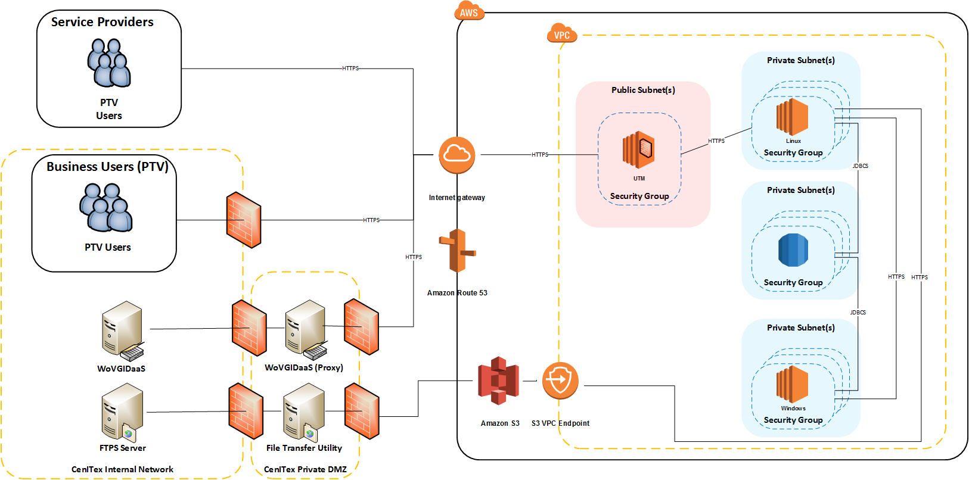

Figure 30: Network Security - Application Perspective

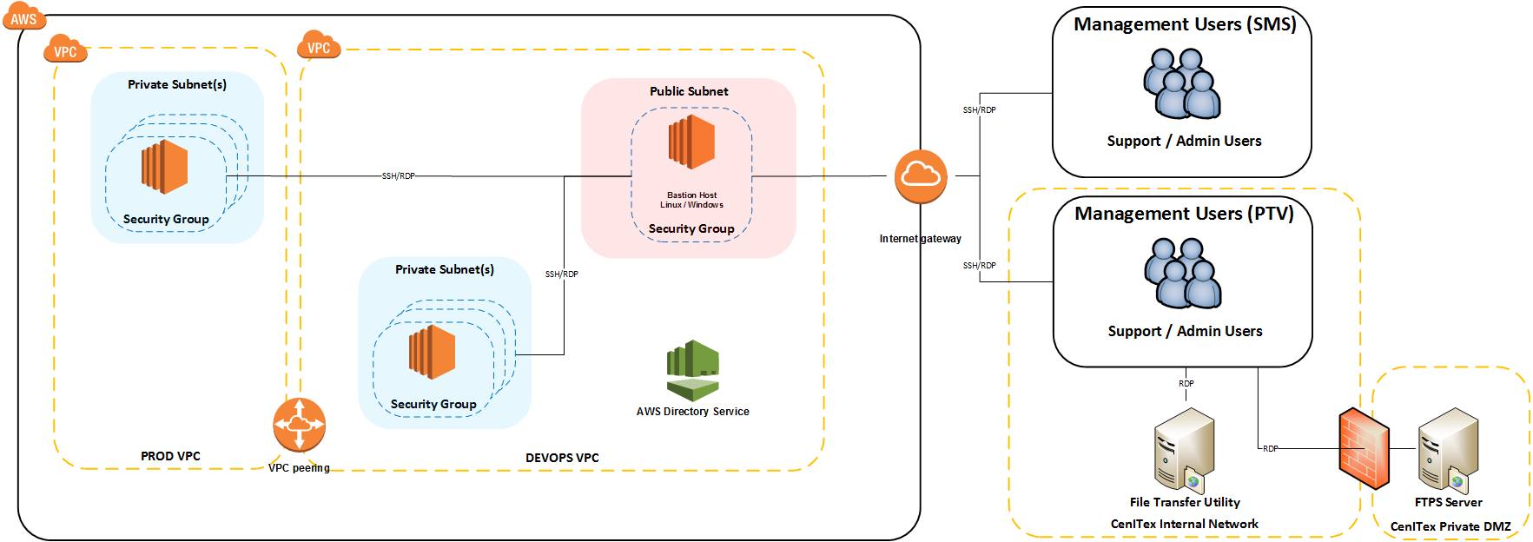

Figure 31: Network Security - Management Perspective

## System Security

All changes to Production environments will be performed by trained and authorised personnel and all change will go through PTV change management process.

A governance structure will be created to authorise access to AWS console and production systems including following controls:

* Role-based access, including strict control of who has administrative access
* Enforcement of security policies
* Application of strict password-policy for both AWS platform and Pega application
* Use of administrative accounts that have the minimum necessary privileges
* All administrative users to have individual accounts, managed by AWS Directory Service
* Centralised logging of activity and access within AWS using Cloudtrail
* Centralised logging of application activity using AWS CloudWatch
* Integration of AWS Directory Service and IAM to provide managed access to AWS Services/Console,
* Use of jump boxes to allow more accurate tracking of user action in the AWS platform
* All keys created in the AWS environment will be generated/managed using AWS KMS service
* Keys for encryption of data exchanged with Oracle Financials will be created by RedRock (technical owners of Oracle Financials), and stored in a secure vault by SMS Managed Services (as operators of the SPPS solution).

To ensure integrity of the system is maintained, the following additional security controls will be implemented:

* Application of a password policy for Pega and AWS users that enforces sufficient complexity, rotation and limits reuse. In addition, multi-factor authentication will also be applied for all access to AWS consoles and UTM devices.
* Key-based authentication (with keys protected by passphrase) for all user and system-based SSH connectivity, namely:
  + External connectivity to AWS bastion hosts
  + Connectivity from bastion hosts to other AWS servers.
  + Connectivity from AWS Lambda functions to other AWS servers
* Hardening of all Windows and Linux AWS EC2 servers
* All Windows/Linux servers joined to AWS Directory Service managed domain.
* Distinct privileged user accounts to administer AWS servers, managed by AWS Directory Service
* Securing email communication by:
  + Password protecting all attachments sent externally to PTV
  + Sending email over a TLS-protected connection
  + Authenticating email with Sender Policy Framework (SPF) to prevent email spoofing
  + Authenticating email with DomainKeys Identified Mail (DKIM) to ensure it is not tampered with in-transit.
  + Authorising only a single email address to send email outbound from SPPS.

## Data Security

### Data at rest

All SPPS data stored in database infrastructure is visible only to the application layer and has no public access. All the data is hosted inside a secure zone. Access to this data is restricted at various levels. Only Platform administrators and application services (Pega, JasperReport Library, Jasper ETL, and Qlik Sense) will have access to the database layer.

The Pega and Reporting databases are hosted by AWS as a service using RDS. No server-access is available. The data stored at rest is encrypted.

Within the Pega database, data is generally stored as BLOBs and only reports specific data is exposed in text columns. All the passwords for external users will be encrypted in Pega.

In the Reporting database, data will be stored as text columns.

S3 buckets are utilised throughout the solution for several purposes, namely as a transit mechanism for exchanging files with Oracle Financials, and as a target destination for Report Objects (both new and migrated from PASS). Server-side encryption will be applied to all S3 buckets.

The persistent data stored in the Report Object Repository will be further secured utilising multi-factor authentication for delete, versioning of the objects in the bucket (enabling restoration to earlier undeleted version) as well as authorisation for deletion of objects/buckets limited by IAM policies.

Application log files and Operating system logs for all components of SPPS will be sent to AWS CloudWatch for secure storage and permission-based viewing.

The following non-production environments will need to have full/partial production data stored at rest. This will be driven by test planning that how much production data is required in non-production environments for respective testing. These environments will strictly follow Production Level protocol (as defined above this section) for data security in these environments:

* Pega Application Development stream
  + System Integration Environment
  + User Acceptance Test Environment
  + Pre-Production Environment
* Data Migration stream [will need full production data in all environments]
  + Development Environment
  + System Test Environment
  + Production Support Environment
* Reporting Solution stream
  + Development Environment
  + System Test Environment
  + User Acceptance Test Environment

Data access is on an as needs basis and the project will work on the least privilege model “Only the minimum necessary rights should be assigned to a subject that requests access to a resource and should be in effect for the shortest duration necessary”.

### Data in Transit

All file transfer channels to the application and database will be encrypted:

* All file upload/download traffic between AWS and CenITex will be via REST over HTTPS, with payloads encrypted.
* All user credentials are transported over HTTPS.

All access channels to the application will be encrypted:

* All web traffic to SPPS Portal (internal, external, reports) will be over HTTPS.
* All traffic to AWS console will be over HTTPS.

All email sent over a TLS-protected connection with DKIM authentication to ensure it is not tampered with in-transit.

### Exceptions

Following exceptions have been recorded to the security of data at rest and security for this data will be same as in PASS system:

* Data printed as part of Bulk Printing function in SPPS solution is secured at physical level and will follow same security protocol as for PASS.

## Application Security

The following section describes how the application addresses key security aspects in accordance with the non-functional requirements.

### Access

All access channels to the application will be encrypted:

• All web traffic to SPPS Portals (internal, external, analytics) will be over HTTPS.

• All traffic to AWS console will be over HTTPS.

### Authentication

Authentication for Pega and Qlik Sense will be based on the CenITex Whole of Victorian Government Identity as a Service (WoVGIDaaS), which will be integrated using SAML and provide Single Sign-on.

Authentication for the AWS platform will be provided by AWS Identity and Access Management (IAM) service, and will leverage AWS Directory Service integration.

Password complexity/lifecycle for internal users is managed by existing CenITex policy as part of Single Sign-On .No multi-factor authentication will be required for these users. For external (Service Providers), password complexity/lifecycle and multi-factor authentication policies will be enforced as part of delivery of the Portal.

### Authorisation

Role-based authorisation will be utilised to ensure that users are granted access only to the minimal level of access that their job role entails. Roles and allocation of users to those roles will be managed separately in Pega and Qlik Sense. Each user of the system will be required to have an individual account.

Prior to implementation, processes will be established with external Service providers to ensure that only authorised user should access the information.

## Time Source Security

The time source for all AWS environments will be a server in the DevOps VPC. This server will be time synchronised to a standard time source within the AWS AU region. Isolating the definitive time source from the application systems will reduce the risk of security compromise.

The time source for servers in the CenITex environment (internal and perimeter) are synced to their local domain controllers, which provide NTP services.

## User Client Security

All desktops/laptops for internal staff will use PTV SOE operation system including required antivirus and disk encryption (if required).

All external users should be instructed to use the system over approved and tested browsers.

# Glossary, Appendix & Attachments

## Glossary

| Term /Acronym | Definition / Expansion / Description |
| --- | --- |
| AWS | Amazon Web Services (Amazon Cloud Platform) |
| AWS EC2 | Amazon Elastic Compute Cloud |
| Azure | Microsoft Cloud Platform |
| BAU | Business As Usual |
| BPM | Business Process Management |
| BPMS | Business Process Management Solution |
| EC2 | Amazon Elastic Compute Cloud (Amazon EC2) |
| ENV / Env | Environment |
| ETL | Extract Transform Load – a design pattern used for the conversion of data from one system to another.  Extract – extract the data from source system(s)  Transform – transform the data extracted to suit the target system data requirement  Load – load the data into the target system |
| FTP | File Transport Protocol |
| HTTP | Hyper Text Transfer Protocol |
| HTTPS | Secure Hyper Text Transfer Protocol |
| LDAP | Lightweight Directory Access Protocol |
| LDAP/S | Lightweight Directory Access Protocol over SSL |
| MSR | Monthly Statistics Returns |
| NTP | Network Time Protocol |
| OOTB | Out Of The Box |
| OPSM | Operator Payment System Modernisation |
| PASS BUS IT | Current Payment System to manage Country and Regional bus services, Airport bus services, NightRider bus services, school bus services and Ferry services and associated payments |
| PASS OPR | Current System for Operator Performance management |
| PASS Payment | Current Payment System for to manage Metro Trains, VLine trains and Yarra Trams contracts and payments |
| Pega | Short for Pegasystems, when referred as company. Also used to refer Pega Platform. |
| PoC | Proof of Concept |
| PPRC | Pega Rules Process Commander |
| PTV | Public Transport Victoria |
| S3 | Amazon Simple Storage Service (Amazon S3) |
| SES | Amazon Simple Email Service (Amazon SES) |
| SFTP | SSH File Transport Protocol |
| SMTPS | Simple Mail Transport Protocol over SSL/TLS |
| SPPS | Service Provider Payment System |
| SSL | Secure Sockets Layer |
| SSO | Single Sign-on |
| TDE | Transparent Data Encryption |
| TLS | Transport Layer Security |
| VPC | AWS Virtual Private Cloud |
| SIA | Security Impact Assessment |

## Appendix

| Appendix | Title |
| --- | --- |
|  |  |
|  |  |